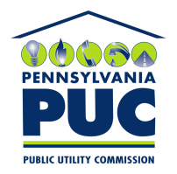 | COMMONWEALTH OF PENNSYLVANIA  PENNSYLVANIA PUBLIC UTILITY COMMISSION  400 North Street, Keystone Building, Second Floor  Harrisburg, Pennsylvania 17120 | IN REPLY PLEASE REFER TO OUR FILE
December 8, 2016

Greg Bass
Calpine Energy Solutions LLC
401 West A Street Suite 500
San Diego CA 92101

RE: Incomplete Bond
Calpine Energy Solutions LLC
Docket Number A-110141

Dear Mr. Bass:

Please find under cover of this letter the financial instrument filed by Calpine Energy Solutions LLC (formerly Noble Americas Energy Solutions LLC) because it is not acceptable.

The Commission requires a supplier to file an original bond, letter of credit, continuation certificate, amendment, or other financial instrument as part of a supplier’s licensing requirements under Section 2809(c) of the Pennsylvania Public Utility Code, including naming the Pennsylvania Public Utility Commission as the beneficiary or obligee of the security instrument along with all other required information on the document.

The bond language is based on an outdated template. Please revise using the most recent version of the template (available on the Commission website and also attached).

Please file the corrected, originally signed and sealed security instrument with my office within 20 days of the date of this letter, preferably by overnight delivery.

Sincerely,

Rosemary Chiavetta
Secretary of the Commission

Enclosures
RC:alw

