BEFORE THE
PENNSYLVANIA PUBLIC UTILITY COMMISSION

PENNSYLVANIA PUBLIC UTILITY COMMISSION :
BUREAU OF INVESTIGATION AND ENFORCEMENT :
:
V. : DOCKET NO. C-2016-2577001
:
RASIER – PA LLC :
114 SOUTH 13TH STREET THIRD FLOOR :
PHILADELPHIA PA 19107 :

COMPLAINT

The Pennsylvania Public Utility Commission (Commission) is a duly constituted agency of the Commonwealth of Pennsylvania empowered to regulate public utilities within the Commonwealth. The Commission has delegated its authority to initiate proceedings which are prosecutory in nature to the Bureau of Investigation and Enforcement and other bureaus with enforcement responsibilities. Pursuant to that delegated authority and Section 701 of the Public Utility Code, the Bureau of Investigation and Enforcement Prosecutory Staff hereby represents as follows:

1. That Rasier – PA LLC, Respondent, maintains a principal place of business at 114 South 13th Street, Third Floor, Philadelphia, Pennsylvania, 19107.

2. That Respondent was issued a certificate of public convenience by this Commission August 21, 2014, at Application Docket No. A-2014-2416127 authorizing transportation of persons in experimental authority.

3. That on November 21, 2016, at approximately 8:45 PM, PUC Motor Carrier Enforcement Officer Ryan Balestra observed a Chevrolet Equinox with an illuminated yellow roof light that read “AVAILABLE,” driving across the Smithfield Street Bridge, Pittsburgh, Allegheny County. Officer Balestra pulled the vehicle over. The driver, Jerome McCree, stated he was working under Respondent’s authority. He displayed an Uber “U” decal on the windshield as specified in the PUC Order of January 29, 2015, granting experimental authority to Rasier-PA, LLC.

4. That Respondent, by affixing a taxi dome light to the roof of the vehicle, violated 75 Pa. C.S. §4307. Dome lights are only permitted on vehicles operated by call and demand carriers or food delivery vehicles. The penalty for this violation is $500.

WHEREFORE, the Bureau of Investigation and Enforcement Prosecutory Staff hereby requests that the Commission fine Rasier – PA, LLC, the sum of five hundred dollars ($500.00) for the illegal activity described in this Complaint.

Respectfully submitted,


David W. Loucks, Chief
Motor Carrier Enforcement
Bureau of Investigation and Enforcement
P.O. Box 3265
Harrisburg, PA 17105-3265

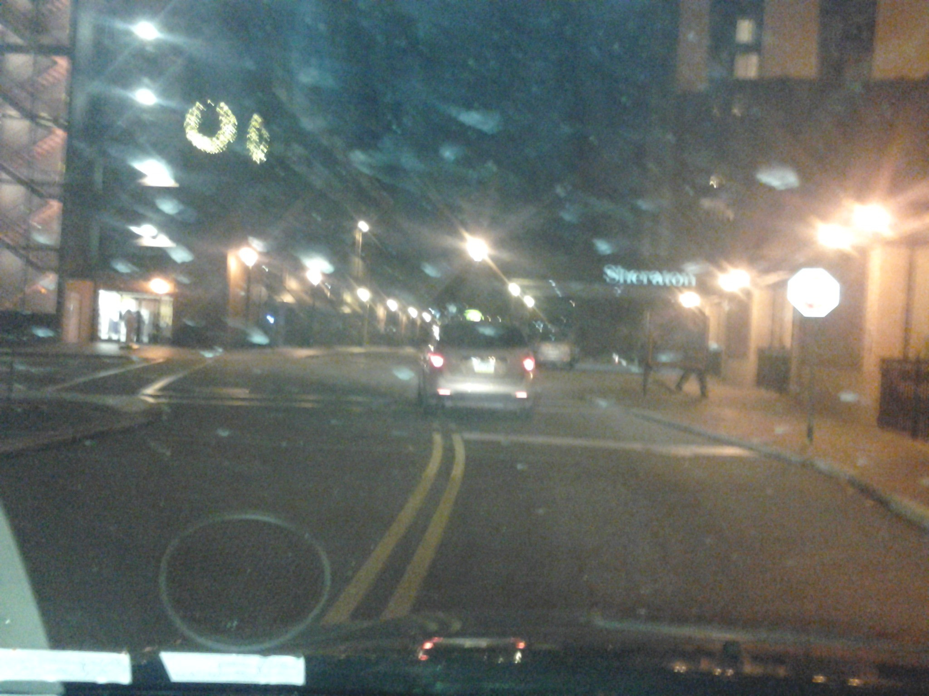

ATTACHMENT A

VERIFICATION

I, David W. Loucks, hereby state that the facts above set forth are true and correct to the best of my knowledge, information and belief and that I expect that the Bureau will be able to prove same at any hearing held in this matter. I understand that the statements herein are made subject to the penalties of 18 Pa. C.S. §4904 relating to unsworn falsification to authorities.

Date: 12/6/16
David W. Loucks, Chief
Motor Carrier Enforcement
Bureau of Investigation and Enforcement

NOTICE
A. You must file an Answer within twenty (20) days of the date of service of this Complaint. The date of service is the mailing date as indicated at the top of the Secretarial Cover Letter for this Complaint and Notice, 52 Pa. Code §1.56(a). An Answer is a written explanation of circumstances wished to be considered in determining the outcome. The Answer shall raise all factual and legal arguments that you wish to claim in your defense and must include the reference number of this Complaint. Your Answer must be verified and the original shall be mailed to:

Rosemary Chiavetta, Secretary
Pennsylvania Public Utility Commission
P.O. Box 3265
Harrisburg, Pennsylvania 17105-3265

Or may be sent by overnight delivery to:
400 North Street, 2nd Floor
Harrisburg, Pennsylvania 17120

Additionally, please serve a copy on:

Michael L. Swindler, Deputy Chief Prosecutor
Bureau of Investigation and Enforcement
Pennsylvania Public Utility Commission
P.O. Box 3265
Harrisburg, Pennsylvania 17105-3265

Or, it may be e-mailed to Mr. Swindler at: RA-PCCmplntResp@pa.gov

B. If you fail to answer this complaint within twenty (20) days, the Bureau of Investigation and Enforcement will request that the Commission issue a Secretarial Letter imposing a penalty. The penalty could include a fine, the suspension or revocation of your certificate of public convenience or other remedy.

C. You may elect not to contest this complaint by paying the fine proposed in this Complaint by certified check or money order. Payment must be made to the Commonwealth of Pennsylvania and should be forwarded to:

Rosemary Chiavetta, Secretary
Pennsylvania Public Utility Commission
P.O. Box 3265
Harrisburg, PA 17105-3265

Your payment is an admission that you committed the alleged violation and an agreement to cease and desist from further violations. Upon receipt of your payment, the complaint proceeding shall be closed.

D. If you file an Answer, which admits or fails to deny the allegations of the Complaint, the Bureau of Investigation and Enforcement will request that the Commission issue a Secretarial Letter imposing a penalty.

E. If you file an Answer which contests the Complaint, the matter will be assigned to an Administrative Law Judge for hearing and decision. The judge is not bound by the optional fine set forth above.

F. Alternative formats of this material are available for persons with disabilities by contacting the Commission’s ADA Coordinator at 717-787-8714.

