PENNSYLVANIA PUBLIC UTILITY COMMISSION

NOTICE TO BE PUBLISHED

Joint Petition of Commonwealth Telephone Company, LLC d/b/a Frontier Communications and US LEC of Pennsylvania, LLC for approval of an Interconnection Opt-In Agreement under Section 252(i) of The Telecommunications Act of 1996.
Docket Number: A-2016-2580806
_____________________

Commonwealth Telephone Company, LLC d/b/a Frontier Communications and US LEC of Pennsylvania, LLC, by its counsel, filed on December 21, 2016, at the Public Utility Commission, a Joint Petition for approval of an Interconnection Opt-In Agreement under Sections 251 and 252 of the Telecommunications Act of 1996.

Interested parties may file comments concerning the petition and agreement with the Secretary, Pennsylvania Public Utility Commission, P.O. Box 3265, Harrisburg, PA 17105-3265. All such Comments are due on or before 10 days after the date of publication of this notice. The documents filed in support of Commonwealth Telephone Company, LLC d/b/a Frontier Communications and US LEC of Pennsylvania, LLC Joint Petition are available for inspection and copying at the Office of the Secretary between the hours of 8:00 a.m. and 4:30 p.m., Monday through Friday, at the Commission’s website at www.puc.pa.gov, and at the applicant’s business address.

Contact person is Cheryl Walker Davis, Director, Office of Special Assistants, (717) 787-1827.

BY THE COMMISSION
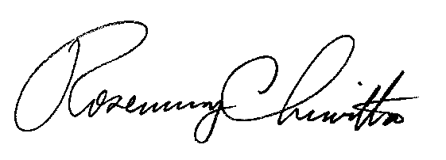

Rosemary Chiavetta
Secretary
RC:AEL

