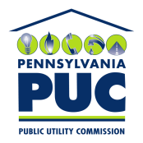 |  | COMMONWEALTH OF PENNSYLVANIA  PENNSYLVANIA PUBLIC UTILITY COMMISSION  400 North Street, HARRISBURG, PA 17120 |  | IN REPLY PLEASE REFER TO OUR FILE  Phone: 717-772-7777
MARCH 3, 2017

MANIVONE VORABOUTH
SANTANNA ENERGY SERVICES
7701 SAN FELIPE BLVD SUITE 200
AUSTIN TX 78729

Dear Sir or Madam:

On February 27, 2017, the Commission received the Application of Santanna Natural Gas Corporation d/b/a Santanna Energy Services for approval to supply natural gas services to the public in the Commonwealth of PA. Upon initial review, the Application has been determined to be deficient for the following reasons:

- Incorrect type of check received. Filing fee must be made either by certified check, money order or check from Attorney. Check # 033899 in the amount of $350.00 is being returned to you. When we receive the correct type of check your application can then be processed.

Pursuant to 52 Pa. Code §1.4, you are being advised of these deficiencies and are required to file corrections. Failure to correct the foregoing deficiencies within 20 days of the date of this letter will result in the Application being returned unfiled.
Please return your items to the above listed address and address to the attention of the Office of the Secretary.
If you have any question in regards to this letter, please contact our bureau at (717) 772-7777. Thank you
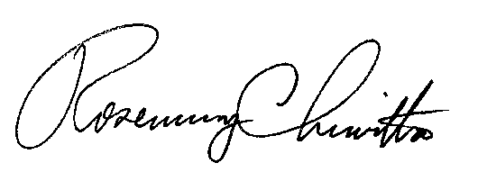
Sincerely,

Rosemary Chiavetta
Secretary

DJ

