COMMONWEALTH OF PENNSYLVANIA
PENNSYLVANIA PUBLIC UTILITY COMMISSION
200 NORTH STREET, KEYSTONE BUILDING SECOND FLOOR
HARRISBURG PA 17120
Formal Complaint
Docket #: C-2017-2593177
Date Served: March 15, 2017

MICHAEL W GANG
ANTHONY D KANAGY
DEVIN T RYAN
POST & SCHELL PC
17 NORTH SECOND STREET 12TH FLOOR
HARRISBURG PA 17101-1601

WILLIAM H ROBERT II
PEOPLES NATURAL GAS COMPANY LLC
375 NORTH SHORE DRIVE
PITTSBURGH PA 15212-5866

RE: PA PUC vs Peoples Natural Gas Company LLC
Rate Case Docket #: R-2017-2586310

Dear : Sir/Madam

A Formal Complaint has been filed against you in the above-captioned matter before the Pennsylvania Public Utility Commission by Office of Small Business Advocate.

This true and correct copy of the complaint has been filed of record with the Pennsylvania Public Utility Commission. Both the Pennsylvania Public Utility Code, 66 Pa. C.S. and the Commission’s regulations at 52 Pa. Code Section 1.53, requires the Commission to serve on each party named in a Formal Complaint a copy of the complaint.

Within ten (10) days from the above date of service, you may either satisfy or answer this complaint in accordance with the provisions of 52 Pa Code, §5.61(d).

When filing your answer to the Formal Complaint, please reference the “Formal Complaint Docket Number” located in the upper-right hand corner of this Notice.

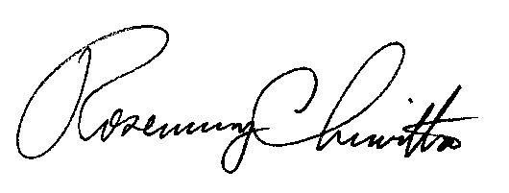
Very Truly Yours,

Rosemary Chiavetta
Secretary

(SEAL)

RC:alw
Certified Mail
Return Receipt Requested

