 | COMMONWEALTH OF PENNSYLVANIA  PENNSYLVANIA PUBLIC UTILITY COMMISSION  400 NORTH STREET, KEYSTONE BULDING SECOND FLOOR  HARRISBURG, PA 17120 | IN REPLY PLEASE REFER TO OUR FILE

March 15, 2017
A-2017-2593475

TISHEKIA WILLIAMS ESQUIRE
DUQUESNE LIGHT COMPANY
411 SEVENTH AVENUE 16TH FLOOR
PITTSBURGH PA 15219

Letter of Notification of Duquesne Light Company filed pursuant to 52 Pa. Code Chapter 57 with respect to reconductor of 6.96 miles of exiting 138 kV Woodville-Peters circuit.

Dear Ms. Williams

Receipt is acknowledged of the Letter of Notification of Duquesne Light Company which has been captioned and docketed to the above number.

This matter will receive the attention of the Commission and you will be advised of any further necessary procedure.

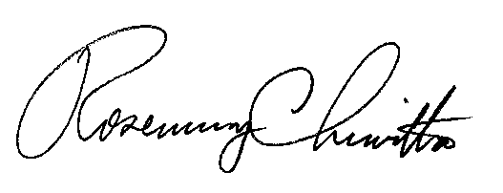
Very truly yours,

Rosemary Chiavetta
Secretary

RC:alw

