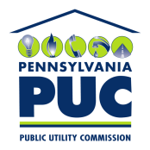 |  | COMMONWEALTH OF PENNSYLVANIA  PENNSYLVANIA PUBLIC UTILITY COMMISSION  400 North Street, HARRISBURG, PA 17120 |  | IN REPLY PLEASE REFER TO OUR FILE  Phone: 717-772-7777

Docket A-2010-2163898
March 20, 2017

Isidro Zambrano Sr Analyst
Credit Group Pacific Summit Energy LLC
4675 MacArthur Court Suite 750
Newport Beach CA 92660

RE: Return of Letter of Credit No. 006221048
Respond Power LLC
EGS License No. A-2010-2163898

Dear Sir:

Please be advised that Letter of Credit No. 006221048 and amendments are being returned as it has been replaced with a new financial instrument.

Sincerely,

Rosemary Chiavetta
Secretary of the Commission

Enclosures
RC: ss

