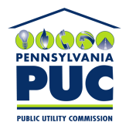 | COMMONWEALTH OF PENNSYLVANIA  PENNSYLVANIA PUBLIC UTILITY COMMISSION  400 NORTH STREET, HARRISBURG, PA 17120
April 12, 2017
Docket No. A-2017-2596069
Utility Code: 1212518

JAMES SPERRY
AERO ENERGY
230 LINCOLN WAY EAST
NEW OXFORD PA 17350-1296

Re: Natural Gas Supplier License Abandonment/Cancellation of Mid-Atlantic Cooperative Solutions Inc. dba Aero Energy

Dear Mr. Sperry:

On March 17, 2017, Mid-Atlantic Cooperative Solutions Inc. dba Aero Energy (Aero Energy) filed an application to abandon its natural gas supplier license. Aero Energy indicated that it has never served any customers and has never collected any sales revenues since being licensed in 2010. Aero Energy was initially licensed on December 3, 2010, to serve residential, small commercial (under 6,000 MCF annually), large commercial (6,000 MCF or more annually), industrial and governmental customers within the natural gas distribution company (NGDC) service territories of Columbia Gas of Pennsylvania, Inc., PECO Energy Company, Philadelphia Gas Works, UGI Central Penn Gas, Inc., UGI Penn Natural Gas, Inc. and UGI Utilities, Inc. within the Commonwealth of Pennsylvania.

There are no outstanding fines pending against Aero Energy. There are also no outstanding formal or informal complaints.

Based on the foregoing, the notification provisions under Title 52, Chapter 62, Subchapter D, Section 62.112 are hereby waived.

We believe that the relinquishment and abandonment of Aero Energy’s license will have no impact on the public, NGDC service territories, or default service providers. Therefore, the Commission approves, by this Secretarial Letter, Aero Energy’s application to abandon its NGS License at Docket No. A-2010-2190632 and its license is cancelled.

The Secretary’s Bureau shall remove the Company’s name from all active status utility lists maintained by the Commission. The Bureau of Administrative Services shall remove the company from all assessment lists.

If you have any questions in this matter, please contact Lee Yalcin of the Bureau of Technical Utility Services at lyalcin@pa.gov or 717-787-6723.

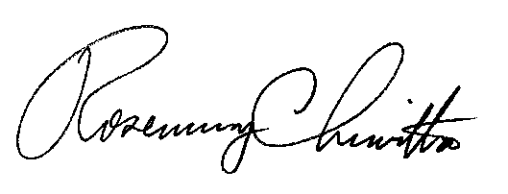
Sincerely,

Rosemary Chiavetta
Secretary

Cc: Office of Consumer Advocate
Office of Small Business Advocate

