PENNSYLVANIA PUBLIC UTILITY COMMISSION

NOTICE TO BE PUBLISHED

Joint Petition of Commonwealth Telephone Company LLC d/b/a Frontier Communications and NEP TelCom Inc. for approval of an Interconnection Agreement under Section 252 (i) of The Telecommunications Act of 1996.
Docket Number: A-2017-2598693
_____________________

Commonwealth Telephone Company LLC d/b/a Frontier Communications and NEP TelCom Inc., by its counsel, filed on April 13, 2017, at the Public Utility Commission, a Joint Petition for approval of an Interconnection Agreement under Sections 251 and 252 of the Telecommunications Act of 1996.

Interested parties may file comments concerning the petition and agreement with the Secretary, Pennsylvania Public Utility Commission, 400 North Street, Harrisburg, PA 17120. All such Comments are due on or before 10 days after the date of publication of this notice. The documents filed in support of Commonwealth Telephone Company LLC d/b/a Frontier Communications and NEP TelCom Inc. Joint Petition are available for inspection and copying at the Office of the Secretary between the hours of 8:00 a.m. and 4:30 p.m., Monday through Friday, at the Commission’s website at www.puc.pa.gov, and at the applicant’s business address.

Contact person is Cheryl Walker Davis, Director, Office of Special Assistants, (717) 787-1827.

BY THE COMMISSION
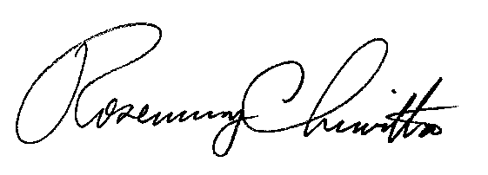

Rosemary Chiavetta
Secretary

