BEFORE THE
PENNSYLVANIA PUBLIC UTILITY COMMISSION

Frederick Altland :
:
v. : C-2017-2582828
:
Metropolitan Edison Company :

INTERIM ORDER
CLOSING THE HEARING RECORD

AND NOW, the transcript of the April 7, 2017 initial hearing in this case having been filed with the Commission’s Secretary’s Bureau in Harrisburg on April 28, 2017; and a copy of the transcript having been received by the undersigned in Pittsburgh on May 1, 2017; and no further hearings in this matter are to be scheduled or held,

THEREFORE,

IT IS ORDERED:

- That the hearing record at Docket No. C-2017-2582828 is closed.

2. That the Initial Decision in this case shall be prepared and issued.
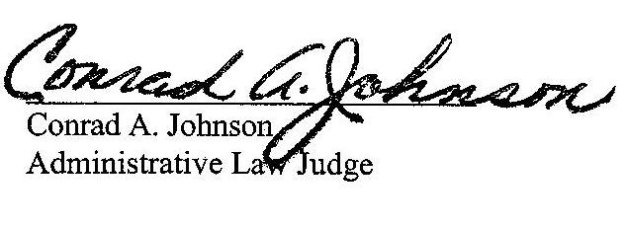

Dated: May 2, 2017

C-2017-2582828 - FREDERICK ALTLAND v. METROPOLITAN EDISON COMPANY
FREDERICK ALTLAND
958 E MARKET STREET
APT 7
YORK PA 17403
717.309.3020
MARGARET A MORRIS ESQUIRE
REGER RIZZO & DARNALL
2929 ARCH STREET 13TH FLOOR
PHILADELPHIA PA 19104
215.495.6524
-E-SERVE-

