 |  | COMMONWEALTH OF PENNSYLVANIA  PENNSYLVANIA PUBLIC UTILITY COMMISSION  400 North Street, HARRISBURG, PA 17120 |  | IN REPLY PLEASE REFER TO OUR FILE  Phone: 717-772-7777
Formal Rate Complaint
Docket #:C-2017-2604117
Date Served: May 15, 2017

UGI CENTRAL PENN GAS INC
PAUL J SZYKMAN VP
2525 NORTH 12TH STREET STE 360
READING PA 19612-2677

RE: PA PUC vs UGI CENTRAL PENN GAS INC
Rate Case Docket #: R-2017-2602627

Dear Mr. Szykman:

A Formal Rate Complaint has been filed against you in the above-captioned matter before the Pennsylvania Public Utility Commission by Office of Small Business Advocate.

This true and correct copy of the complaint has been filed of record with the Pennsylvania Public Utility Commission. Both the Pennsylvania Public Utility Code, 66 Pa. C.S. Section 702, and the Commission’s regulations, 52 Pa. Code Section 1.53, require the Commission to serve on each party named in a Formal Rate Complaint a copy of the complaint.

Within ten (10) days from the above date of service, you may either satisfy or answer this complaint in accordance with the provisions of 52 Pa Code, §5.61(d).

When filing your answer to the Formal Rate Complaint, please reference the “Formal Rate Complaint Docket Number” located in the upper-right hand corner of this Notice.

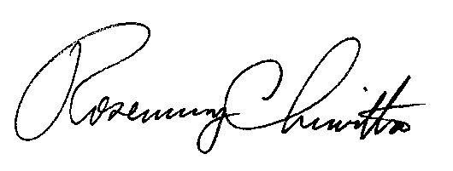
Very Truly Yours,

Rosemary Chiavetta
Secretary

(SEAL)

Certified Mail
Return Receipt Requested
DJ

