BEFORE THE
PENNSYLVANIA PUBLIC UTILITY COMMISSION

Petition of UGI Utilities, Inc. ‒ Gas Division for : P-2013-2398833
Approval of a Distribution System Improvement :
Charge :
:
:
Office of Consumer Advocate :
:
v. : C-2016-2540745 :
UGI Utilities, Inc. ‒ Gas Division :

INTERIM ORDER
CONSOLIDATING THE COMPLAINT FILED IN THIS PROCEEDING, ADMITTING THE SETTLING PARTIES’ JOINT PETITION FOR SETTLEMENT OF ALL ISSUES INTO THE RECORD, AND CLOSING THE RECORD

AND NOW, UGI Utilities, Inc. ‒ Gas Division (UGI-GD) having filed on March 31, 2016, a Petition for Approval of a Distribution System Improvement Charge (DSIC Petition); and the Office of Consumer Advocate (OCA) having filed on April 19, 2016, a Complaint against the DSIC Petition; and UGI-GD, OCA and UGI Industrial Intervenors, the Settling Parties to this proceeding, having filed their Joint Petition for Settlement of All Issues on May 18, 2017; and the Commission’s Bureau of Investigation and Enforcement and the Office of Small Business Advocate both not objecting to the Settlement; and no further hearings in this matter are to be scheduled or held.

THEREFORE,

IT IS ORDERED:

- That the Complaint of the Office of Consumer Advocate at Docket No. C-2016-2540745 is consolidated with UGI Utilities, Inc. ‒ Gas Division’s Petition for Approval of a Distribution System Improvement Charge at Docket No. P-2013-2398833.

- That the Joint Petition for Settlement filed in this proceeding on May 18, 2017, by the Settling Parties, i.e., UGI Utilities, Inc. ‒ Gas Division, the Office of Consumer Advocate and UGI Industrial Intervenors is admitted into the record.

- That the records at Docket Nos. P-2013-2398833 and C-2016-2540745 shall be closed.

4. That the Recommended Decision in this matter shall be prepared and issued.

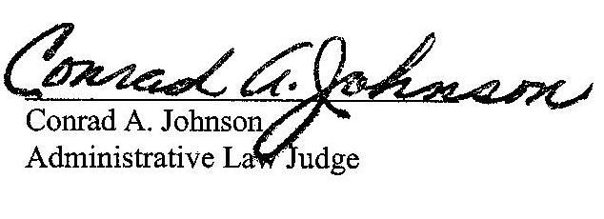

Dated: May 24, 2017

P-2013-2398833 – PETITION OF UGI UTILITIES INC – GAS DIVISION – FOR APPROVAL OF A DISTRIBUTION SYSTEM IMPROVEMENT CHARGE

Revised 5/24/17

JESSICA R ROGERS ESQUIRE
POST & SCHELL PC
SUITE 600
607 14TH STREET NW
WASHINGTON DC 20005-2006
Accepts e-Service

MARK C MORROW ESQUIRE
DANIELLE JOUENNE ESQUIRE
UGI CORPORATION
460 NORTH GULPH ROAD
KING OF PRUSSIA PA 19406
Accepts e-Service

DAVID B MACGREGOR ESQUIRE
POST & SCHELL PC
17 N SECOND STREET 12TH FLOOR
HARRISBURG PA 17101-1601

ERIN L GANNON ESQUIRE
DARRYL LAWRENCE ESQUIRE
OFFICE OF CONSUMER ADVOCATE
555 WALNUT STREET
5TH FLOOR FORUM PLACE
HARRISBURG PA 17101-1923
Accepts e-Service

STEVEN C GRAY ESQUIRE
OFFICE OF SMALL BUSINESS ADVOCATE
300 N SECOND STREET
HARRISBURG PA 17101

CARRIE B WRIGHT ESQUIRE
PA PUBLIC UTILITY COMMISSION
BUREAU OF INVESTIGATION & ENFORCEMENT
PO BOX 3265
HARRISBURG PA 17105-3265
Accepts e-Service

PAMELA C POLACEK ESQUIRE
VASILIKI KARANDRIKAS ESQUIRE
ALESSANDRA L HYLANDER ESQUIRE
MCNEES WALLACE & NURICK LLC
PO BOX 1166
HARRISBURG PA 17108-1166
Accepts e-Service

