COMMONWEALTH OF PENNSYLVANIA
PENNSYLVANIA PUBLIC UTILITY COMMISSION
400 NORTH STREET, HARRISBURG PA 17120
Formal Complaint
Docket #: C-2017-2607455

Date Served: June 5, 2017

ROD NEVIRAUSKAS, DIRECTOR OF RATES
PENNSYLVANIA AMERICAN WATER COMPANY
800 WEST HERSHEY PARK DRIVE
HERSHEY, PA 17033

RE: PA PUC vs PENNSYLVANIA AMERICAN WATER COMPANY
Rate Case Docket #: R-2017-2595853

Dear Sir or Madam:

A Formal Complaint has been filed against you in the above-captioned matter before the Pennsylvania Public Utility Commission by Margaret L. O’Leary.

This true and correct copy of the complaint has been filed of record with the Pennsylvania Public Utility Commission. Both the Pennsylvania Public Utility Code, 66 Pa. C.S. and the Commission’s regulations at 52 Pa. Code Section 1.53, requires the Commission to serve on each party named in a Formal Complaint a copy of the complaint.

Within ten (10) days from the above date of service, you may either satisfy or answer this complaint in accordance with the provisions of 52 Pa Code, §5.61(d).

When filing your answer to the Formal Complaint, please reference the “Formal Complaint Docket Number” located in the upper-right hand corner of this Notice.

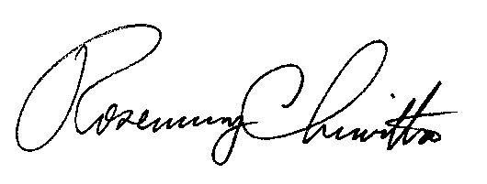
Very Truly Yours,

Rosemary Chiavetta
Secretary

RC: al

(SEAL)
Certified Mail
Return Receipt Requested

