 | COMMONWEALTH OF PENNSYLVANIA  PENNSYLVANIA PUBLIC UTILITY COMMISSION  P.O. BOX 3265, HARRISBURG, PA 17105-3265 | IN REPLY PLEASE REFER TO OUR FILE
May 31, 2017
A-2017-2605434
Utility Code: 230240
Thomas T. Niesen, Esq.
Thomas, Niesen and Thomas, LLC
212 Locust Street, Suite 600
Harrisburg, P A 17101

Dear Attorney Niesen:

Receipt is acknowledged of the Application of Aqua Pennsylvania Wastewater, Inc., (hereinafter referred to as "Aqua" or "Applicant") pursuant to Sections 1102 and 1329 of the Public Utility Code for:
(1) approval of the acquisition by Aqua of the wastewater system assets of Limerick Township ("Township") situated within a portion of Limerick Township and within a portion of the Borough of
Royersford, Montgomery County, Pennsylvania; (2) approval of the right of Aqua to begin to offer, render, furnish and supply wastewater service to the public in a portion of Limerick Township, Montgomery County, Pennsylvania; and (3) an order approving the acquisition that includes the ratemaking rate base of the Limerick Township wastewater system assets pursuant to Section 1329(c)(2) of the Public Utility Code.

It will be necessary for you to serve copies of the Application upon the following parties, then file proof of such service with this Commission, pursuant to 52 Pa. Code, §1.57 and §1.58:

Each city, borough, town, township, county and related planning office which is included, in whole or in part, in the proposed service area;

A water or wastewater utility, municipal corporation or authority which provides water or wastewater collection, treatment and disposal service to the public and whose service area abuts the service area proposed in the application;

And the Department of Environmental Protection’s appropriate regional office.

You are directed upon receipt of this letter to publish the enclosed notice once a week for two consecutive weeks in a newspaper having a general circulation in the area involved and file proof of publication with the Commission on or before June 26, 2017.

Pursuant to 52 Pa. Code §5.14, the Commission will proceed with publishing the attached notice in the Pennsylvania Bulletin. This notice will appear in the Saturday, June 10, 2017 issue.

This matter will receive the attention of the Commission and you will be advised of any further necessary procedure.

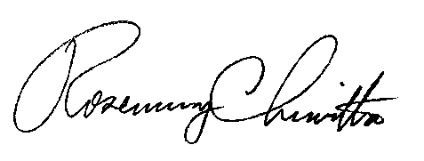
Sincerely,

Rosemary Chiavetta
Secretary
Enclosure

PENNSYLVANIA PUBLIC UTILITY COMMISSION
NOTICE TO BE PUBLISHED

Application of Aqua Pennsylvania Wastewater, Inc., (hereinafter referred to as "Aqua" or "Applicant") pursuant to Sections 1102 and 1329 of the Public Utility Code for: (1) approval of the acquisition by Aqua of the wastewater system assets of Limerick Township ("Township") situated within a portion of Limerick Township and within a portion of the Borough of Royersford, Montgomery County, Pennsylvania; (2) approval of the right of Aqua to begin to offer, render, furnish and supply wastewater service to the public in a portion of Limerick Township, Montgomery County, Pennsylvania; and (3) an order approving the acquisition that includes the ratemaking rate base of the Limerick Township wastewater system assets pursuant to Section 1329(c)(2) of the Public Utility Code. Docket Number: A-2017-2605434.
________________________________________________

Formal protests and petitions to intervene must be filed in accordance with Title 52 of the Pennsylvania Code, on or before June 26, 2017. All filings must be made with the Secretary of the Pennsylvania Public Utility Commission, P. O. Box 3265, Harrisburg, PA 17105-3265, with a copy served on the Applicant. The documents filed in support of the Application are available for inspection and copying at the Office of the Secretary between the hours of 8:00 a.m. and 4:30 p.m., Monday through Friday, on the Commission's website at www.puc.pa.gov, and at the Applicant's business address.

Applicant:

Aqua Pennsylvania Wastewater, Inc.

Through and By Counsel for:

Thomas T. Niesen, Esq.
Thomas, Niesen and Thomas, LLC
212 Locust Street, Suite 600
Harrisburg, P A 17101

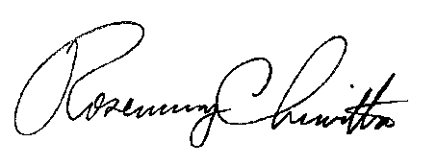
BY THE COMMISSION

Rosemary Chiavetta
Secretary

