 | COMMONWEALTH OF PENNSYLVANIA  PENNSYLVANIA PUBLIC UTILITY COMMISSION  P.O. BOX 3265, HARRISBURG, PA 17105-3265 | IN REPLY PLEASE REFER TO OUR FILE
June 28, 2017

Docket No. A-2017-2605601

Utility Code: 310633
EDWARD G. LANZA
THE LANZA FIRM, LLC
PO BOX 61336
HARRISBURG, PA 17106-1336

Re: Level 3 Communications, LLC
Application for Expanded Authority

Dear Mr. Lanza:

Receipt is acknowledged of the Application of Level 3 Communications, LLC (Applicant) for approval to offer, render, furnish or supply telecommunications services to the public as a Competitive Local Exchange Carrier (CLEC) in the service territory of TDS Telecom/Mahanoy & Mahantango Telephone Company. The Application has been reviewed and found to be in compliance with the Commission’s filing requirements as set out in Re: Implementation of the Telecommunications Act of 1996, Docket No. M-00960799 (Implementation Order: June 3, 1996; and Implementation Reconsideration Order: September 9, 1996) (Implementation Orders).

The instant Application is not eligible for provisional authority under the Implementation Orders.

Pursuant to the Secretary’s discretion, Applicant’s request for a waiver is granted concerning publication in newspapers of general circulation in the applicable service territories.

Pursuant to 52 Pa. Code § 5.14, the Commission’s Secretary’s Bureau will proceed with publishing the attached notice in the Pennsylvania Bulletin. This notice will appear in the Saturday, July 15, 2017 issue.

This matter is being referred to the Bureau of Technical Utility Services for analysis and to schedule it for consideration by the Commission at Public Meeting. Questions concerning this letter may be directed to Mark Lum, Telco Section, Bureau of Technical Utility Services at (717) 783-6185 or mlum@pa.gov.

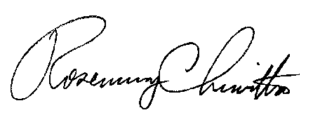
Sincerely,

Rosemary Chiavetta
Secretary

Enclosure

cc: Service List

Service List

Office of Consumer Advocate  555 Walnut St.  5th Floor Forum Place  Harrisburg, PA 17101-1923 | Office of Attorney General  Bureau of Consumer Protection  14th Floor Strawberry Square  Harrisburg, PA 17120 | Office of Small Business Advocate  Commerce Building, Ste. 202  300 North Second ST  Harrisburg, PA 17101
TDS Telecom M&M
Jeff Handley, Government Affairs
10025 Investment Dr., Ste. 100
Knoxville, TN 37932-2665

PENNSYLVANIA PUBLIC UTILITY COMMISSION

NOTICE TO BE PUBLISHED

Application of Level 3 Communications, LLC for approval to Offer, Render, Furnish or Supply Telecommunications Services to the Public as a Competitive Local Exchange Carrier in the Service Territory of TDS Telecom/Mahanoy & Mahantango Telephone Company. Docket Number: A-2017-2605601.
___________________________________________

Formal protests and petitions to intervene must be filed in accordance with Title 52 of the Pennsylvania Code, on or before July 31, 2017. All filings must be made with the Secretary of the Pennsylvania Public Utility Commission, P. O. Box 3265, Harrisburg, PA 17105-3265, with a copy served on the Applicant. The documents filed in support of the Application are available for inspection and copying at the Office of the Secretary between the hours of 8:00 a.m. and 4:30 p.m., Monday through Friday, on the Commission’s website at www.puc.pa.gov, and at the Applicant's business address.

Applicant:

Level 3 Communications, LLC

Through and By Counsel:

Edward G. Lanza
The Lanza Firm, LLC
PO Box 61336
Harrisburg, PA 17106-1336

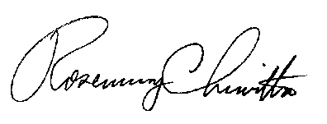
BY THE COMMISSION

Rosemary Chiavetta
Secretary

