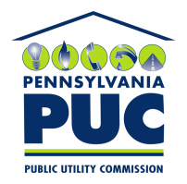 | COMMONWEALTH OF PENNSYLVANIA  PENNSYLVANIA PUBLIC UTILITY COMMISSION  400 NORTH STREET, KEYSTONE BUILDING, SECOND FLOOR  HARRISBURG, PENNSYLVANIA 17120 | IN REPLY PLEASE REFER TO OUR FILE

July 17, 2017

Via First Class Mail

Josh Dover
M & T Bank
1800 Washington Blvd MC-MD1-MP37 8th Floor
Baltimore MD 21230

RE: Letter of Credit Amendment
Jack Rich Inc. d/b/a Anthracite Power and Light
A-110094

Dear Mr. Dover:

We are in receipt of your letter requesting approval of the Letter of Credit Amendment you sent to us on June 29, 2017. Because the Amendment did not have a signature for the surety company, is was returned to you under the enclosed cover letter on July 11, 2017, sent Certified Mail # 9171 9690 0935 0143 6572 81.

Once we have received the Amendment with a signature from the Surety Company, we will review it to sign and process as appropriate.

Sincerely,

Rosemary Chiavetta
Secretary of the Commission

RC: alw
Enclosures

CC: Jack Rich Inc., c/o Vasiliki Karandrikas, 100 Pine St PO Box 1166, Harrisburg Pa 17108
(letter only)

