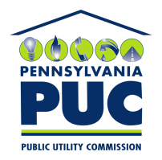 | COMMONWEALTH OF PENNSYLVANIA  PENNSYLVANIA PUBLIC UTILITY COMMISSION  400 NORTH STREET, HARRISBURG, PA 17120 | IN REPLY PLEASE REFER TO OUR FILE

July 20, 2017

VIA FIRST CLASS MAIL AND eSERVICE

Honorable Perry Warren
Pennsylvania House of Representatives
Room 27B, East Wing
Main Capitol Building
Harrisburg, Pennsylvania 17120

RE: Pennsylvania American Water Company
Docket Number R-2017-2595853

Dear Representative Warren:

Thank you for your letter dated July 13, 2017, to Executive Director Jan Freeman regarding the above captioned proposed rate case filed by the Pennsylvania American Water Company.

Since this matter is still pending before the Pennsylvania Public Utility Commission, and due to the statutory prohibition on ex-parte communications at 66 Pa. C.S. Section 334(c), please be advised that I am serving a copy of your comments to all of the parties of record to this case, and placing your letter on the record at the above docket number.

I have copied June Perry, the Commission’s Legislative Director, with your letter, and who can also provide you with more information on how to monitor the litigation of this rate case.

Sincerely,

Rosemary Chiavetta
Secretary of the Commission

Enclosure
CC: All Parties of Record
June Perry, PUC Legislative Director

