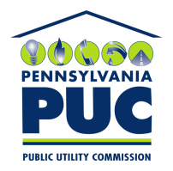 | COMMONWEALTH OF PENNSYLVANIA  PENNSYLVANIA PUBLIC UTILITY COMMISSION  400 NORTH STREET, KEYSTONE BUILDING, SECOND FLOOR  HARRISBURG, PENNSYLVANIA 17120 | IN REPLY PLEASE REFER TO OUR FILE

August 2, 2017

Via Certified Mail

Dina Freedman
Alpha Gas & Electric LLC
971 Route 45 Suite 202
Pomona NY 10970

RE: Continuation Certificate
Alpha Gas & Electric LLC
A-2011-2254554

Dear Sir/Madam:

Please find under cover of this letter the updated financial instrument filed with the Commission on behalf of Alpha Gas & Electric LLC because it is a copy and not acceptable.

The Commission requires a supplier to file an original bond, letter of credit, continuation certificate, amendment, or other financial instrument as part of a supplier’s licensing requirements under Section 2809(c) of the Pennsylvania Public Utility Code.

The enclosed financial instrument does not have a "wet ink" original signature or raised seal for the surety company. Please file the original signed and sealed financial instrument with my office within 20 days of the date of this letter, preferably by overnight delivery to my office address listed above.

Sincerely,

Rosemary Chiavetta
Secretary of the Commission

RC: alw
Enclosures

