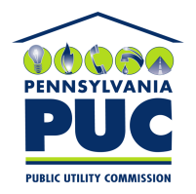 | COMMONWEALTH OF PENNSYLVANIA  PENNSYLVANIA PUBLIC UTILITY COMMISSION  400 NORTH STREET, HARRISBURG, PA 17105-3265 | IN REPLY PLEASE REFER TO OUR FILE
August 18, 2017

JOSEPH ISAACS, MANAGING DIRECTOR
ONIX ENERGY LLC
580 SYLVAN AVENUE, SUITE 2J
ENGELWOOD CLIFFS, NJ 07632

Dear Mr. Isaacs:

On August 11, 2017, the Commission received the Application of Onix Energy LLC for approval to supply natural gas services to the public in the Commonwealth of PA. Upon initial review, the Application has been determined to be missing information for the following reasons:

- No Original Signature

- The filing fee must be a certified check or money order made payable to the Commonwealth of Pennsylvania.

Pursuant to 52 Pa. Code §1.4, you are being advised of this missing information and are required to file corrections. Failure to correct the foregoing deficiencies within 20 days of the date of this letter will result in the Application being returned unfiled.
Please return your items to the above listed address and address to the attention of the Office of the Secretary.
If you have any question in regards to this letter, please contact our bureau at (717) 772-7777. Thank you
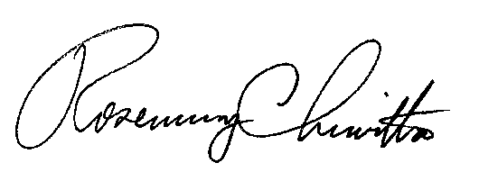
Sincerely,

Rosemary Chiavetta
Secretary

Enclosure

RC:AEL

