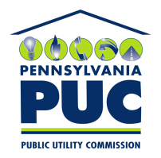 | COMMONWEALTH OF PENNSYLVANIA  PENNSYLVANIA PUBLIC UTILITY COMMISSION  400 North Street, Keystone Building, Second Floor  Harrisburg, Pennsylvania 17120 | IN REPLY PLEASE REFER TO OUR FILE
September 5, 2017

Laura Edwards
US Energy Consulting Group LLC
1275 66th Street N 49221
Saint Petersburg FL 33710

RE: Duplicate Financial Instrument
US Energy Consulting Group LLC
A-2013-2392573

Dear Ms. Edwards:

Please find under cover of this letter the Continuation Certificate filed with the Commission on behalf of US Energy Consulting Group LLC because it is a duplicate of the document already on file.

The Commission requires a supplier to file a current and active original bond, letter of credit, continuation certificate, amendment, or other financial instrument as part of a supplier’s licensing requirements under Section 2809(c) of the Pennsylvania Public Utility Code.

Please see previous letter, also attached, regarding updates to the necessary language in financial instruments filed with the Commission.

Sincerely,

Rosemary Chiavetta
Secretary of the Commission

Enclosures
RC:alw

