 | COMMONWEALTH OF PENNSYLVANIA  PENNSYLVANIA PUBLIC UTILITY COMMISSION  400 NORTH STREET, HARRISBURG, PA 17120 | IN REPLY PLEASE REFER TO OUR FILE
October 2, 2017

KAMILA SERWIN, SENIOR COMPLIANCE ANALYST
AURORA ENERGY ADVISORS LLC
1528 WALNUT STREET, 22ND FLOOR
PHILADELPHIA, PA 19102

Dear Ms. Serwin:

On September 21, 2017, the Commission received the Application of Aurora Energy Advisors LLC for approval to supply natural gas services to the public in the Commonwealth of PA. Upon initial review, the Application has been determined to be missing information for the following reason:

- No Original Signature

Pursuant to 52 Pa. Code §1.4, you are being advised of this missing information and are required to file corrections. Failure to correct the foregoing missing information within 20 days of the date of this letter will result in the Application being returned unfiled.
Please return your items to the above listed address and address to the attention of the Office of the Secretary.
If you have any question in regards to this letter, please contact our bureau at (717) 772-7777. Thank you
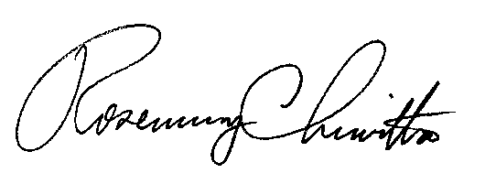
Sincerely,

Rosemary Chiavetta
Secretary

Enclosure

RC:AEL

