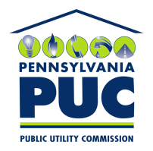 | COMMONWEALTH OF PENNSYLVANIA  PENNSYLVANIA PUBLIC UTILITY COMMISSION  400 North Street, Keystone Building, Second Floor  Harrisburg, Pennsylvania 17120 | IN REPLY PLEASE REFER TO OUR FILE
October 31, 2017

Via Certified Mail

US Energy Consulting Group LLC
1275 66th Street North #49221
St Petersburg FL 33710

RE: Updated Bond
US Energy Consulting Group LLC
A-2013-2392573

Dear Sir/Madam:

Please find under cover of this letter the updated financial instrument filed with the Commission on behalf of US Energy Consulting Group LLC because it is not acceptable.

The Commission requires a supplier to file an original bond, letter of credit, continuation certificate, amendment, or other financial instrument as part of a supplier’s licensing requirements under Section 2809(c) of the Pennsylvania Public Utility Code.

The Bond you filed does not contain a signature by the Principal for US Energy Consulting Group LLC at the bottom of the document. The document must include an original "wet" signature, preferably in blue ink, and a raised seal or original notary stamp, indicating that the Principal agrees to the security.

Sincerely,

Rosemary Chiavetta
Secretary of the Commission

RC: alw
Enclosures

