COMMONWEALTH OF PENNSYLVANIA
PENNSYLVANIA PUBLIC UTILITY COMMISSION
Commonwealth KEYSTONE BUILDING 400 NORTH STREET 2nd FLOOR
HARRISBURG PA 17120
Corrected Formal Complaint Notice
Docket #: C-2017-2633476

Date Served: November 28, 2017

PHILIP J WOOD JR DIRECTOR
VERIZON PA LLC
417 WALNUT STREET 1ST FLOOR
HARRISBURG PA 17101
RE: PA PUC vs VERIZON PA LLC
Rate Case Docket #: R-2017- 2632523

Dear Sir/Madam

A Formal Complaint has been filed against you in the above-captioned matter before the Pennsylvania Public Utility Commission by the Office of Small Business Advocate.

This true and correct copy of the complaint has been filed of record with the Pennsylvania Public Utility Commission. Both the Pennsylvania Public Utility Code, 66 Pa. C.S. and the Commission’s regulations at 52 Pa. Code Section 1.53, requires the Commission to serve on each party named in a Formal Complaint a copy of the complaint.

Within ten (10) days from the above date of service, you may either satisfy or answer this complaint in accordance with the provisions of 52 Pa Code, §5.61(d).

When filing your answer to the Formal Complaint, please reference the “Formal Complaint Docket Number” located in the upper-right hand corner of this Notice.

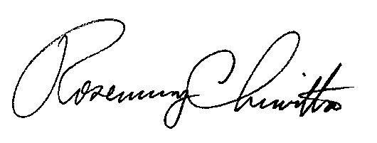
Very Truly Yours,

Rosemary Chiavetta
Secretary

(SEAL)

RC:mm
Certified Mail
Return Receipt Requested

