 | COMMONWEALTH OF PENNSYLVANIA  PENNSYLVANIA PUBLIC UTILITY COMMISSION  400 NORTH STREET 2ND FLOOR HARRISBURG PA 17120 | IN REPLY PLEASE REFER TO OUR FILE

November 30, 2017

Docket No. A-2017-2625563

SAMUEL ADJANGBA
ADVISORS ENERGY GROUP LLC
PO BOX 3108
LINDEN NJ 07036

Receipt is acknowledged of your Reply to Data Request received in this Office on November 22, 2017. The Commission’s Rules of Administrative Practice and Procedure, set forth in Title 52 PA Code require that your answers to the data request should be verified per 52 Pa Code § 1.36. Accordingly, you must submit a signed verification statement with your answers

Please sign and date in ink as indicated by the tab stating ‘Please Sign & Date’ and return the verification statement to the address listed at the top of this letter within 10 days.

Once we receive your signed verification statement we will be able to process as needed. If you do not return it within 10 days your filing will be considered unfiled.

Thank you for your attention to this matter.

Sincerely,
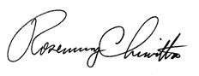
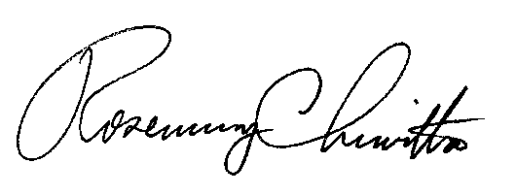

Rosemary Chiavetta
Secretary

RC:mm

§1.36 Verification.

(a) Applications, petitions, formal complaints, motions and answers thereto containing an averment of fact not appearing of record in the action or containing a denial of fact shall be personally verified by a party thereto or by an authorized officer of the party if a corporation or association. Verification means a signed written statement of fact supported by oath or affirmation or made subject to the penalties of 18 Pa. C.S. §4904 (relating to unsworn falsification to authorities). If verification is required, notarization is not necessary.

A-2017-2625563

§1.36 Verification.

Verification
_________

I, _______________________________, hereby state that the facts above set forth are true and correct (or are true and correct to the best of my knowledge, information and belief), and that I expect to be able to prove the same at a hearing held in this matter. I understand that the statements herein are made subject to the penalties of 18 Pa. C.S. § 4904 (relating to unsworn falsification to authorities).

________________ _____________________________________
Date Signature

