BEFORE THE
PENNSYLVANIA PUBLIC UTILITY COMMISSION

Ronald Brooks :
:
v. : F-2017-2633508
:
Philadelphia Gas Works :

INTERIM ORDER
DIRECTING COMPLAINANT TO PRODUCE
PROTECTION FROM ABUSE ORDER

The Complainant, Ronald Brooks (Complainant) filed a formal complaint against Philadelphia Gas Works (PGW). In his complaint, Mr. Brooks checked the box noting that a court has granted him a Protection from Abuse Order (PFA) for his personal safety or welfare. Accordingly, it is the practice of the Commission to protect the Complainant’s address, telephone number and account numbers in all filings that are typically made public.

An initial telephonic hearing is scheduled in this matter for Wednesday, February 28, 2018.

THEREFORE,

IT IS ORDERED:

1. That until directed otherwise, the Complainant will be given in this proceeding the protections accorded an individual having received a Protection from Abuse Order. Any filings made with the Commission shall protect the Complainant’s address, telephone number, account number and any other identifying information.

2. That on or before January 10, 2018, the Complainant shall mail to me and counsel for PGW a true and correct copy of a Court-issued Protection from Abuse Order that is currently in effect for his protection, or evidence of any pending court action to renew a Protection from Abuse Order.

3. That if I do not receive a true and correct copy of a Protection from Abuse Order or evidence of a pending court action to renew a Protection from Abuse Order on or before January 10, 2018, Complainant, will not be given in this proceeding the protections normally accorded an individual having received a Protection from Abuse Order.
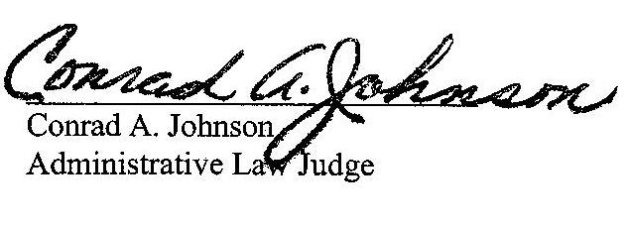

Date: December 26, 2017

F-2017-2633508 - RONALD BROOKS v. PHILADELPHIA GAS WORKS
RONALD BROOKS **PFA**
GRACIELA CHRISTLIEB ESQUIRE
PHILADELPHIA GAS WORKS
800 WEST MONTGOMERY AVENUE
PHILADELPHIA PA 19122
215.684.6164
-E-SERVE-

