BEFORE THE
PENNSYLVANIA PUBLIC UTILITY COMMISSION

Florence Ackridge :
:
v. : F-2017-2613068
:
Philadelphia Gas Works :

ERRATA NOTICE

This is to advise all parties of record that the Initial Decision dated January 8, 2018, in the above-captioned proceeding contains a typographical error on Page 1, HISTORY OF THE PROCEEDING, Paragraph 2, which read as follows:

On July 27, 2017, Respondent filed an Answer admitting that the Company did terminate Complainant’s electric service for an unpaid balance and denying that there are incorrect charges on Complainant’s bill.

The typographical error should be corrected to read gas.

A corrected Page 1 is attached to this Errata Notice. Except for the above correction, the Initial Decision and Order remains in effect in all other respects. This correction will not affect the exception period established by the Commission’s Secretary’s Service Letter dated January 11, 2018.

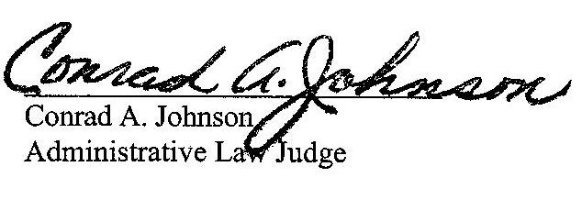

Date: January 22, 2018

BEFORE THE
PENNSYLVANIA PUBLIC UTILITY COMMISSION

Florence Ackridge :
:
v. : F-2017-2613068
:
Philadelphia Gas Works :

INITIAL DECISION

Before
Conrad A. Johnson
Administrative Law Judge

This decision dismisses the Complaint filed in this matter for failure of Complainant to appear for the hearing and prosecute the Complaint.

HISTORY OF THE PROCEEDING

On July 3, 2017, Florence Ackridge (Complainant) filed a Complaint with the Pennsylvania Public Utility Commission (Commission) against Philadelphia Gas Works (Respondent). Complainant checked the boxes on the Formal Complaint form stating 1) the utility is threatening service termination or has already terminated service, and 2) incorrect charges are on my bill.

On July 27, 2017, Respondent filed an Answer admitting that the Company did terminate Complainant’s gas service for an unpaid balance and denying that there are incorrect charges on Complainant’s bill.

By notice dated August 8, 2017, the Commission scheduled this matter for a call in telephonic hearing on September 11, 2017 at 10:00 a.m. and assigned the case to me.
F-2017-2613068 - FLORENCE ACKRIDGE v. PHILADELPHIA GAS WORKS
FLORENCE ACKRIDGE
6713 GRATZ STREET
PHILADELPHIA PA 19126
GRACIELA CHRISTLIEB ESQUIRE
PHILADELPHIA GAS WORKS
800 WEST MONTGOMERY AVENUE
PHILADELPHIA PA 19122
215.684.6164
Accepts E-service
Representing Philadelphia Gas Works

