BEFORE THE
PENNSYLVANIA PUBLIC UTILITY COMMISSION

Lisa Johnson :
:
v. : C-2017-2616938
:
Pennsylvania Power Company :

INTERIM ORDER
DIRECTING COMPLAINANT TO PROVIDE MEDICAL DOCUMENTATION AND TAKING MOTION TO DISMISS UNDER ADVISEMENT

Pursuant to a Hearing Cancellation/Reschedule Notice issued to the Parties on December 6, 2017, I convened the initial telephonic hearing in this case on January 26, 2018, at 10:01 a.m. Counsel for Respondent Pennsylvania Power Company, Margaret A. Morris, Esquire, was present for the hearing, and she was accompanied by two witnesses. Complainant Lisa Johnson was not present. However, Dave Moffatt, a friend of Complainant, was present. Mr. Moffatt represented that Ms. Johnson had a medical emergency earlier that morning, and he had just taken her to Jameson Hospital, New Castle, Pennsylvania.

Attorney Morris submitted that the hearing was previously scheduled for December 5, 2017, and on the morning of the hearing Complainant called into the Commission’s Office of Administrative Law Judge claiming a medical emergency and requesting a hearing continuance, which was granted. Consequently, Attorney Morris moved for dismissal of the Complaint with prejudice for Complainant’s failure to appear for the hearing and prosecute her Complaint. The motion was taken under advisement.

I directed Mr. Moffatt to inform Ms. Johnson that by Friday, February 9, 2018, she must provide documentation to me and Attorney Morris verifying that she received medical treatment at Jameson Hospital the morning of January 26, 2018.

The below order confirms Respondent’s motion and my directive to Mr. Moffatt.

ORDER

THEREFORE,

IT IS ORDERED:

1. That Complainant Lisa Johnson shall provide documentation that on the morning of Friday, January 26, 2018, she received medical treatment at Jameson Hospital, New Castle, Pennsylvania; the medical documentation shall be provided to the undersigned Administrative Law Judge and counsel for Respondent Pennsylvania Power Company, Margaret A. Morris, Esquire, by Friday, February 9, 2018.

2. That Respondent Pennsylvania Power Company shall file an objection(s), if any, to the medical documentation provided by Complainant Lisa Johnson by Monday, February 19, 2018.

3. That Respondent Pennsylvania Power Company’s motion to dismiss the Complaint with prejudice for Complainant Lisa Johnson’s failure to appear for the hearing and prosecute her Complaint is taken under advisement.

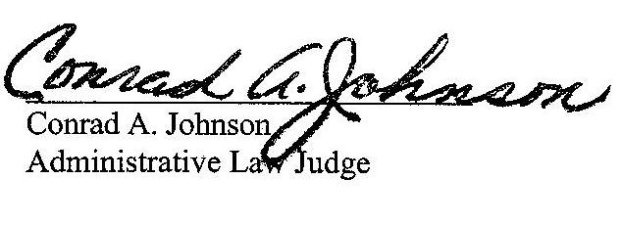

Date: January 26, 2018

C-2017-2616938 - LISA JOHNSON v. PENNSYLVANIA POWER COMPANY
LISA JOHNSON
352 HALCO DR
NEW CASTLE PA 16101
724.856.8506
MARGARET A MORRIS ESQUIRE
REGER RIZZO & DARNALL
2929 ARCH STREET 13TH FLOOR
PHILADELPHIA PA 19104
215.495.6524
Accepts E-service
Representing Pennsylvania Power Company

