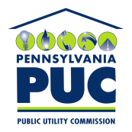 | COMMONWEALTH OF PENNSYLVANIA  PENNSYLVANIA PUBLIC UTILITY COMMISSION  400 North Street, HARRISBURG, PA 17120 | IN REPLY PLEASE REFER TO OUR FILE

Date of Service: January 29, 2018 Docket Number: C-2018-2644592

RALPH SCARTELLI
WINOLA WATER COMPANY
724 NORTH WEBSTER AVENUE
SCRANTON, PA 18510

Bureau of Investigation and Enforcement
v.
WINOLA WATER COMPANY

Dear Sir/Madam:

The Pennsylvania Public Utility Commission has delegated its authority to initiate prosecutory proceedings to several of its Commission bureaus with enforcement responsibilities. Pursuant to this delegated authority and Section 701 of the Public Utility Code, 66 Pa. C.S. § 701, Bureau of Investigation and Enforcement staff has filed the attached Complaint against you seeking a monetary penalty and/or revocation of your Certificate of Public Convenience.

Very truly yours,


Rosemary Chiavetta
Secretary

RC:AEL

