 | COMMONWEALTH OF PENNSYLVANIA  PENNSYLVANIA PUBLIC UTILITY COMMISSION  400 NORTH STREET, HARRISBURG, PA 17120 | IN REPLY PLEASE REFER TO OUR FILE
February 12, 2018

TRI M. VO, PRESIDENT
PROVISION POWER AND GAS, LLC
P.O. BOX 6036
AUSTIN, TX 78762

Dear Mr. Vo:

On January 17, 2018, the Commission received the Application of Provision Power & Gas LLC for approval to supply natural gas services to the public in the Commonwealth of PA. A missing information letter was sent on January 25, 2018 stating the item needed to process your application. The missing information has been received on January 31, 2018. However, the Application has been still determined to be missing information for the following reason:

- Some pages of the confidential information appear to be so blurred that they are unreadable. The pages included Exhibits 6b-D and Pages 28 – 29, 31 – 32, 34 – 35, 37 – 39, 42, 44 – 45, 47 – 48, 50, 52 and 54 of Exhibit 6b-F2. (These pages have been flagged for your convenience.)

Pursuant to 52 Pa. Code §1.4, you are being advised of this missing information and are required to file corrections. Failure to correct the foregoing missing information within 20 days of the date of this letter will result in the Application being returned unfiled.
Please return your items to the above listed address and address to the attention of the Office of the Secretary.
If you have any question in regards to this letter, please contact our bureau at (717) 772-7777. Thank you
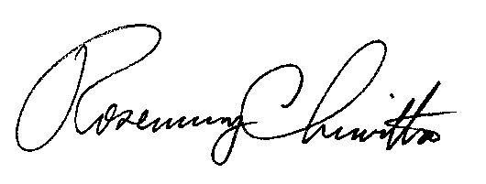
Sincerely,

Rosemary Chiavetta
Secretary

Enclosure

RC:AEL

