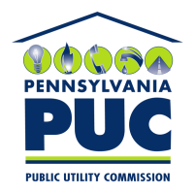 | COMMONWEALTH OF PENNSYLVANIA  PENNSYLVANIA PUBLIC UTILITY COMMISSION  400 NORTH STREET, HARRISBURG, PA 17120 | IN REPLY PLEASE REFER TO OUR FILE
January 25, 2018

TRI M. VO, PRESIDENT
PROVISION POWER & GAS LLC
P.O. BOX 6036
AUSTIN, TX 78762

Dear Mr. Vo:

On January 17, 2018, the Commission received the Application of Provision Power & Gas LLC for approval to supply natural gas services to the public in the Commonwealth of PA. Upon initial review, the Application has been determined to be missing information for the following reasons:

- No Original Signature

- No $350.00 filing fee. The filing fee must be a certified check or money order made payable to the Commonwealth of Pennsylvania.

- Proofs of Publication must be in their original form. Copies of Proofs of Publication will not be accepted.

- CD-rom copy must be condensed into less than 10 or less PDF documents.

Pursuant to 52 Pa. Code §1.4, you are being advised of this missing information and are required to file corrections. Failure to correct the foregoing missing information within 20 days of the date of this letter will result in the Application being returned unfiled.
Please return your items to the above listed address and address to the attention of the Office of the Secretary.
If you have any question in regards to this letter, please contact our bureau at (717) 772-7777. Thank you
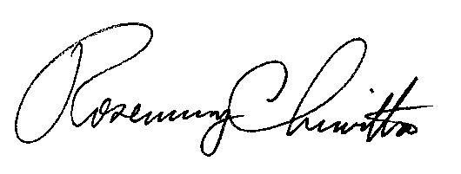
Sincerely,

Rosemary Chiavetta
Secretary

Enclosure

RC:AEL

