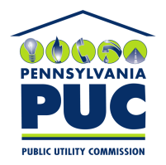 | COMMONWEALTH OF PENNSYLVANIA  PENNSYLVANIA PUBLIC UTILITY COMMISSION  400 NORTH STREET, HARRISBURG, PA 17120 | IN REPLY PLEASE REFER TO OUR FILE
March 13, 2018

BRADLEY R. LEWIS
13900 NICKLAUS DRIVE
OVERLAND PARK, KS 66223

Dear Mr. Lewis:

On March 12, 2018, the Commission received the Application of Bradley R. Lewis for approval to supply natural gas services to the public in the Commonwealth of PA. Upon initial review, the Application has been determined to be deficient for the following reasons:

- No $350.00 filing fee

- No Tax Certification Form
Pursuant to 52 Pa. Code §1.4, you are being advised of these deficiencies and are required to file corrections. Failure to correct the foregoing deficiencies within 20 days of the date of this letter will result in the Application being returned unfiled.
Please return your items to the above listed address and address to the attention of the Office of the Secretary.
If you have any question in regards to this letter, please contact our bureau at (717) 772-7777. Thank you
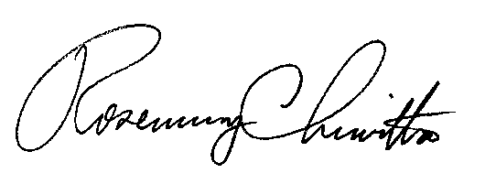
Sincerely,

Rosemary Chiavetta
Secretary

Enclosure

RC:AEL

