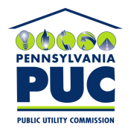 | COMMONWEALTH OF PENNSYLVANIA  PENNSYLVANIA PUBLIC UTILITY COMMISSION  400 NORTH STREET, HARRISBURG, PA 17120 | A-2018-3000657

March 23, 2018

Docket No: A-2018-3000657

KYLE FLANAGAN
GREYLOCK PRODUCTION LLC
500 CORPORATE LANDING
CHARLESTON, WV 25311

Re: Annual Pipeline Operator Registration

Dear Mr. Flanagan:

This letter acknowledges the receipt of your company’s Pipeline Operator Registration Form. The docket number assigned to your company is

A-2018-3000657. Please refer to this number in all future correspondence with the Pennsylvania Public Utility Commission.

Should you have any questions pertaining to your registration, please contact the Bureau of Technical Utility Services at 717-787-9382, or email your questions to ra-Act127@pa.gov.

Sincerely,

Rosemary Chiavetta

Secretary

