 | COMMONWEALTH OF PENNSYLVANIA  PENNSYLVANIA PUBLIC UTILITY COMMISSION  P.O. BOX 3265, HARRISBURG, PA 17105-3265 | IN REPLY PLEASE REFER TO OUR FILE

April 18, 2018
A-2013-2374997
TO ALL PARTIES

Application of the Department of Transportation of the Commonwealth of Pennsylvania for the approval to alter the at-grade crossing by the installation of automatically operated flashing-light railroad crossing warning signals with short arm gates where Diller Avenue crosses, at grade, (DOT 517 759 D) a single track of Norfolk Southern Railway Company in New Holland Borough, Lancaster County; all in accordance with the Federal Highway Grade Crossing Safety Program; and the allocation of costs incident thereto.

To Whom It May Concern:

A final inspection conducted by a Commission staff engineer on April 6, 2018 revealed that all work has been completed to the satisfaction of the parties involved and as per the Commission’s Secretarial Letter’s dated July 3, 2014 and March 3, 2017 approving the subject application, allocation of costs, plans modification and assignment of the future maintenance responsibilities.

The Commission thereby issues this Secretarial Letter in accordance with Section 2702 of the Public Utility Code and finds that since all work has been completed, the case be “CLOSED.”

If you are dissatisfied with the resolution of this matter, you may, as set forth in 52 Pa. Code §§ 1.31 and 5.44, file a Petition for Reconsideration from Staff Action (Petition) with the Commission within twenty (20) days of the date of this letter. The Petition shall be sent to: Secretary, PA Public Utility Commission, P.O. Box 3265, Harrisburg, PA 17105-3265, and must be filed within twenty (20) days, or if no timely request is made, the action will be deemed to be a final action of the Commission.

The Petition MUST include: (1) a written statement (divided into numbered paragraphs) outlining the reasons for the request; (2) the case docket number (it is provided for you at the top right hand corner of this letter); (3) the party on whose behalf the petition is made; (4) a Certificate of Service on the other parties of record; and (5) a Verification with original signature in accordance with 52 Pa. Code § 1.36.

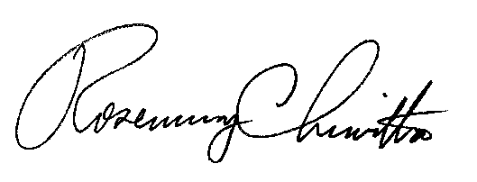
Very truly yours,

Rosemary Chiavetta
Secretary

