PENNSYLVANIA
PUBLIC UTILITY COMMISSION

Harrisburg, PA 17105-3265

 | Public Meeting held April 19, 2018
Commissioners Present:

Gladys M. Brown, Chairman
Andrew G. Place, Vice Chairman
Norman J. Kennard
David W. Sweet
John F. Coleman, Jr.

PPL Electric Utilities Corporation Universal Service and Energy Conservation Plan for 2017-2019 Submitted in Compliance with 52 Pa. Code § 54.74. | Docket No. M-2016-2554787

ORDER
BY THE COMMISSION

On February 5, 2018, in response to a Public Utility Commission (Commission) Order entered on October 5, 2017 (October 5 Order) at this docket, PPL Electric Utilities Corporation (PPL or Company) filed a proposed “zero-income” addendum (Addendum A), with an verification form, to its 2017-2019 Universal Service and Energy Conservation Plan (USECP) which would allow customers reporting no income to enroll in OnTrack (i.e., PPL’s customer assistance program or CAP). On February 14, 2018, the Commission issued a Secretarial Letter establishing a timeframe for comments and reply comments on PPL’s proposed Addendum A and proposed form. The Coalition for Affordable Utility Services and Energy Efficiency in Pennsylvania (CAUSE-PA) filed comments, and PPL filed reply comments.

Background

In compliance with Commission regulations, PPL submitted its Proposed 2017-2019 Plan on June 30, 2016. On April 6, 2017, the Commission entered a Tentative Order requesting additional information. On May 3, 2017, the Commission issued a Secretarial Letter (May 3 Secretarial Letter) clarifying some of the information requested in the Tentative Order. PPL filed further comments in response on May 18, 2017, and May 25, 2017. CAUSE-PA and the Office of Consumer Advocate (OCA) individually filed comments on June 7, 2017. CAUSE-PA, OCA, and PPL individually filed reply comments on June 22, 2017.

On October 5, 2017, the Commission entered its October 5 Order directing PPL to, inter alia, work with its universal service stakeholder group to draft a zero-income form and establish program parameters for enrolling households with no income into OnTrack. The Company was directed to file an addendum and zero-income form within 60 days after final approval of its 2017-2019 USECP. The Commission approved PPL’s 2017-2019 USECP in an Order entered on December 7, 2017.

On January 25, 2018, PPL held a Universal Service Advisory Group (USAG) meeting with stakeholders and presented its proposed zero-income policy and zero-income form for discussion.

On February 5, 2018, PPL filed its proposed Addendum A to the 2017-2019 USECP and its zero-income form. On February 14, 2018, the Commission issued a Secretarial Letter requesting comments on PPL’s proposal. On February 22, 2018, CAUSE-PA filed comments. On March 2, 2018, PPL filed reply comments.

PPL’s Proposed Addendum A and Proposed Zero-Income Form

The proposed Addendum A and proposed zero-income form would allow customers reporting no income to enroll in OnTrack if they complete a zero-income form declaring that they have no income and explaining how they meet basic living expenses. Customers applying through a paper OnTrack application would receive the zero-income form from the local OnTrack agency after the customers submit their initial applications. Customers applying online would be able to provide the required zero-income information immediately if they enter “zero” for their income on the online application. Proposed Addendum A at 1.

PPL would place applicants reporting zero income into OnTrack Lifestyle, which requires participants to recertify their income every nine months. These customers would be charged OnTrack’s minimum payment option. Addendum A at 1.

CAUSE-PA Comments

CAUSE-PA has several concerns about the zero-income enrollment policy and form proposed by PPL, some of which are based on PPL’s filing and some of which are based in information that CAUSE-PA asserts was received at the January 25, 2018 USAG meeting.

First, CAUSE-PA notes that the zero-income form has many open-ended questions that a customer may intentionally leave blank. However, the zero-income form includes a disclaimer that PPL may dismiss the OnTrack application if the customer does not provide the requested information. CAUSE-PA recommends that PPL be “lenient” when information is missing from the form. If there is sufficient information provided to verify the customer has no income, the form should be accepted. If there is insufficient or questionable information, the OnTrack agency should attempt to contact the customer and obtain the information prior to rejecting the application. CAUSE-PA Comments at 2-3.

Second, CAUSE-PA contends that PPL’s proposal to mail the customer a zero-income form only after PPL receives a completed OnTrack application is time-consuming and cumbersome. CAUSE-PA posits that customers waiting for OnTrack approval may lose service unnecessarily due to this extended application process. CAUSE-PA recommends that PPL pend termination for 15 days to give the customer time to return the zero-income form. Alternatively, CAUSE-PA recommends that PPL include the zero-income form with the OnTrack application. CAUSE-PA Comments at 3-4.

Finally, CAUSE-PA requests clarification on whether PPL will allow customers to enroll in OnTrack if they truly have no income. CAUSE-PA states that, at the January 25 USAG meeting, a PPL employee suggested that a household without any income and no means of paying a bill will not be eligible for OnTrack. CAUSE-PA Comments at 4-5.

PPL Reply Comments

PPL clarifies that it will not reject zero-income forms if they sufficiently explain the household has no income. PPL also clarifies that having no income or resources will not disqualify a customer from OnTrack. Specifically:

PPL Electric believes that its addendum and proposed form are consistent with CAUSE-PA’s first and third recommendation[s], but concedes that how [PPL Electric] intends to use the form could use clarification. PPL Electric intends to enroll customers with zero income into OnTrack, meaning that customers do not need to identify resources on the zero income [sic] form if none exist. However, even when customers have no resources to meet basic needs (i.e., food, housing, and utilities), the customer is expected to complete the form by stating this on the form.

PPL Reply Comments at 3.

PPL opposes CAUSE-PA’s recommendations that the Company either (1) give the customer time to complete and return the zero-income form by suspending termination activity for 15 days or (2) include the zero-income form with the OnTrack application. The Company contends that including the zero-income form with the paper application could increase the risk of fraud and potentially the cost of the OnTrack program. PPL Reply Comments at 3-4.

PPL Electric submits that reserving the zero income form for just the customers who identify themselves as having no income will reduce the opportunity for customers with incomes from simply completing and submitting the zero income form. Further, as provided in the addendum, if a customer applies online, the customer can complete the zero income form immediately upon entering zero in the income field. PPL Electric submits that in the case of a customer facing imminent termination, the quickest method for that customer is to apply for OnTrack using the online application. Further, PPL Electric expects to start its telephonic OnTrack application in 2018, which will be another method for customers to enroll in OnTrack quickly without mailing delays.

PPL Reply Comments at 4.

Discussion

PPL has complied with the directives in our October 5 Order to meet with its USAG and to submit for review a proposed zero-income policy and zero-income form. PPL’s proposes to require customers reporting no income to complete a form explaining how they pay for household expenses.

CAUSE-PA now challenges aspects of PPL’s proposed zero-income policy and use of the proposed form. CAUSE-PA asserts that the zero-income customers who mail their OnTrack applications have an unreasonably greater risk of being disconnected than zero-income customers who apply online.

In considering PPL’s proposed zero-income policy and form for OnTrack, we have reviewed the approved zero-income policies and forms used by other utilities when verifying that a customer applying for CAP has no income. A few examples are:

- Duquesne Light Company’s (Duquesne) CAP program requires customers who report no household income at the time of enrollment to complete a zero-income form and give Duquesne permission to verify the income with government agencies such as the Internal Revenue Service and through bankruptcy proceedings. Duquesne requests that the customer identify all household members at the address where service is provided and provide a brief explanation of how household expenses are met on the form. The customer must sign and date the form. The customer’s income status may be reviewed every six months to determine if employment or income status has changed. Duquesne provides customers with an opportunity to challenge or correct income information provided by third parties prior to dismissal from the program. See Duquesne’s 2017-2019 USECP (filed on May 12, 2017) at 5-6, Docket No. M-2016-2534323.

- Philadelphia Gas Works’ (PGW) CAP program requires customers reporting zero income to complete a form explaining how they meet basic living expenses for housing, food, and utilities. PGW does not require documentation of these living expenses but will request proof of housing expenses during periodic CAP reviews. See PGW 2017-2020 USECP (filed on August 31, 2017) at 16, Docket No. M-2013-2366301.

- The UGI Companies (UGI Gas, UGI Penn Natural Gas, UGI Central Penn Gas, and UGI Electric) require customers who report zero household income at the time of CAP enrollment and recertification to complete a zero-income form. The zero-income form must be filled out by the individual who holds the account with UGI. The following information is required: (1) customer name; (2) date of application; (3) account number; (4) service address; (5) a list of adult household members with zero income; and (6) an explanation of how household expenses were met for food and shelter during the applicable period. The zero-income form must be signed by both the account holder and a CAP agency representative. By signing the zero-income form, the customer provides consent to the UGI Companies to verify income with government agencies. See UGI 2014-2017 USECP (filed on February 17, 2015) at 20, Docket No. M-2013-2371824.

We understand CAUSE-PA’s concern that mailing a zero-income form to the customer after receipt of an OnTrack application may delay enrollment for these customers. However, we find that there is little record evidence to support the concerns regarding potential disconnects during the pendency of an application for CAP by a customer claiming zero income. We also find that there is no record evidence to support the claim that providing a hard copy of zero-income form with an initial CAP application will increase the risk of fraudulent claims of zero-income, especially since the online customer has immediate access to the zero-income form questions once the assertion of zero income is made. In point of fact, since PPL has not previously allowed customers claiming zero income into its OnTrack, PPL has no experience upon which to base its claims that the inclusion of zero-income form with the OnTrack application will increase customer attempts at fraud. Thus, we find both the arguments of both parties to be speculative.

The Commission has previously given utilities flexibility in determining their requirements when enrolling zero -income customers into CAPs. We are not aware whether other utilities routinely provide zero-income forms with their CAP applications. Further, we have no data on how customers choose between applying via paper or online applications for CAP.

While we will not require that PPL include the zero-income form with the paper OnTrack application, we shall require PPL to track the number of customers who are placed into collection or termination status or actually terminated within 30 days of submitting a paper OnTrack application claiming zero income. The Company should provide this information as part of its 2020-2022 USECP, which should be filed and served by August 1, 2019.

Accordingly, we shall not require changes to PPL’s proposed zero-income policy and form at this time. However, PPL shall comply with the reporting requirement established herein. The Company should implement this new policy as of the entry date of this Order.

Conclusion

We conclude that PPL has satisfied the requirements in our October 5 Order by seeking stakeholder input on its proposed zero-income policy and form and submitting the proposed policy and form for our review. We shall allow PPL’s proposed zero-income policy and proposed form to be implemented upon entry of this Order, consistent with this Order and subject to the reporting requirement established herein.

Having addressed PPL’s Petition and the comments and reply comments in the record, we note that any issue, comment, or reply comment requesting a further deviation from the PPL’s Petition, but which we may not have specifically delineated herein, shall be deemed to have been duly considered and denied without further discussion. The Commission is not required to consider expressly or at length each contention or argument raised by the parties. Consolidated Rail Corp. v. Pa. PUC, 625 A.2d 741 (Pa. Cmwlth. Ct., 1993); see also, generally, U. of PA v. Pa. PUC, 485 A.2d 1217 (Pa. Cmwlth. Ct., 1984); THEREFORE,

IT IS ORDERED:

1. That the Petition to Amend the 2017-2019 Universal Service and Energy Conservation Plan, as filed by PPL Electric Utilities Corporation on February 5, 2018 is approved consistent with this Order.

2. That PPL Electric Utilities Corporation shall begin enrolling customers with no income into its OnTrack program, consistent with the Addendum A, including the zero-income form, as of the entry date of this Order.

3. That PPL Electric Utilities Corporation shall track the number of customers who are placed into termination or disconnected within thirty (30) days of submitting a paper OnTrack application claiming zero income. This information should be provided with the Company’s 2020-2022 Universal Service and Energy Conservation Plan, which should be filed and served by August 1, 2019.

4. That a copy of this Order be served on PPL Electric Utilities Corporation, the Office of the Consumer Advocate, the Office of Small Business Advocate, the Bureau of Investigation and Enforcement, the Public Utility Law Project, and the Coalition for Affordable Utility Services and Energy Efficiency in Pennsylvania.

BY THE COMMISSION,

Rosemary Chiavetta
Secretary

(SEAL)
ORDER ADOPTED: April 19, 2019
ORDER ENTERED: April 19, 2018

Appendix

Proposed Addendum A and zero-income form

Addendum A
2.1. a. Eligibility Criteria for Participation in the Program with Zero Income
OnTrack is now available to customers with zero income, as long as they submit a completed "Zero Income Form" which states how they are meeting their basic expenses. Customers submitting paper applications will receive the Zero Income Form from the OnTrack agency in their area. Customers submitting online applications will be able to provide this information as part of the online application when they enter zero for their income.
Zero income customers will be placed into a temporary program called OnTrack Lifestyle (explained in section 2.3), where they are required to provide updated income information after nine months. Zero income customers will receive an OnTrack amount based on the minimum payment option (section 4.2). The Company acknowledges that this will still exceed the Commission's maximum energy burden levels.

Zero-Income Form
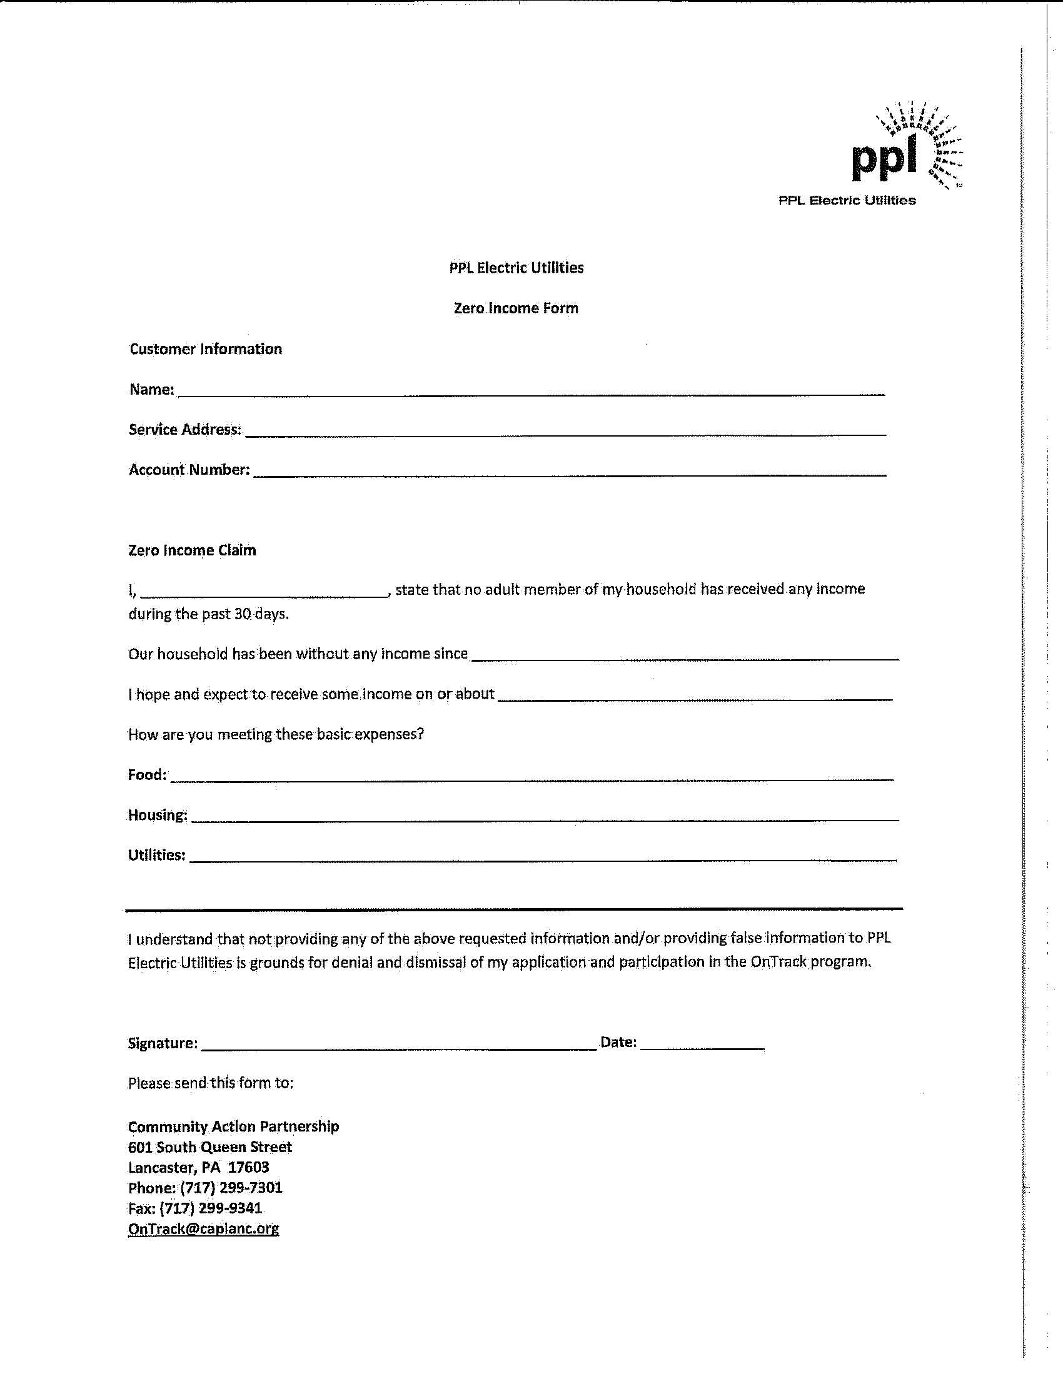

The proposed Addendum A and zero-income form are attached as an Appendix of this Order.
Energy utilities, including PPL, often use community-based organizations (CBOs) to administer various aspects of their universal service programs. See, e.g., PPL’s 2017-2019 USECP at 30-32.
The proposed zero-income form contains the direction to “send this form” to PPL’s agent in Lancaster and provides a street address and an email address.
PPL’s minimum payment option calculates the OnTrack payment amount by taking the customer’s estimated monthly budget amount and subtracting the maximum monthly OnTrack credit amount (i.e., $185/month for an electric heat customer or $73/month for a non-electric heat customer within the 101% to 150% of the Federal Income Poverty Guidelines or FPIG income level) and adding a $5 arrearage co-payment (if the customer has pre-program arrearage). PPL 2017-2019 USECP at 5. PPL acknowledges that monthly bills for customers will exceed the Commission’s recommended maximum energy burden levels. Proposed Addendum A at 1, citing Pa. Code 52 Section 69.265(2)(A-C).

