 | COMMONWEALTH OF PENNSYLVANIA  PENNSYLVANIA PUBLIC UTILITY COMMISSION  400 NORTH STREET, HARRISBURG, PA 17120 | IN REPLY PLEASE REFER TO OUR FILE

5/1/2018

C-2018-3001451

SUNOCO PIPELINE, L.P.
TEN PENN CENTER 17TH FLOOR
1801 MARKET STREET
PHILADELPHIA, PA 19103-1699

Pennsylvania State Senator Andrew E. Dinniman
v
Sunoco Pipeline, LP

Dear Sir/ Madam:

Attached is copy of an amended complaint filed on behalf of the complainant in the above titled proceeding.

Such answer as you desire to make to the amended complaint should be filed in this Office and served upon the complainant within twenty days from receipt of this letter.

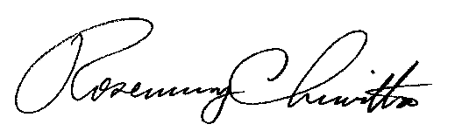
Very truly yours,

Rosemary Chiavetta
Secretary

RC:jbs

