May 18, 2018
A-2018-3002020

ANTHONY D KANAGY
POST & SCHELL, PC
17 NORTH SECOND STREET, 12TH FLOOR
HARRISBURG, PA 17101-1601

Dear Sir/Madam:

Receipt is acknowledged of the Application of Transource Pennsylvania LLC for approval to acquire a certain portion of the lands of J. Daniel & Elaine J. Eshleman in Washington Township, Franklin County, Pennsylvania for the siting and construction of the 230 kV Transmission Line associated with the Independence Energy Connection - East Project is necessary or proper for the service, accommodation, convenience of safety of the public, which has been captioned and docketed to the above number.

This matter will receive the attention of the Commission and you will be advised of any further necessary procedure.

Sincerely,
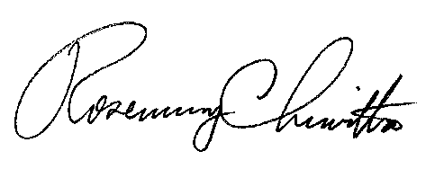

Rosemary Chiavetta
Secretary

RC:jht

