 | COMMONWEALTH OF PENNSYLVANIA  PENNSYLVANIA PUBLIC UTILITY COMMISSION  400 NORTH STREET, HARRISBURG, PA 17120 | IN REPLY PLEASE REFER TO OUR FILE
April 12, 2018

NAVEEN RABIE, ESQUIRE
ENGIE RESOURCES LLC
1990 POST OAK BOULEVARD, SUITE 1900
HOUSTON, TX 77056

Dear Mr. Rabie:

On April 6, 2018, the Commission received the Application of ENGIE Resources LLC for approval to supply natural gas services to the public in the Commonwealth of PA. Upon initial review, the Application has been determined to be missing information for the following reasons:

- Bond No. 925131 in the amount of $35,000.00 bound in favor of PECO Energy Company [dated March 9, 2018] is not required in this application. This bond is being returned to you. Please serve us a Bond Letter from PECO Energy Company.

- The signatures on the Proofs of Publication from The Philadelphia Daily News and The Williamsport Sun-Gazette must be original.

Pursuant to 52 Pa. Code §1.4, you are being advised of this missing information and are required to file corrections. Failure to correct the foregoing missing information within 20 days of the date of this letter will result in the Application being returned unfiled.
Please return your items to the above listed address and address to the attention of the Office of the Secretary.
If you have any question in regards to this letter, please contact our bureau at (717) 772-7777. Thank you
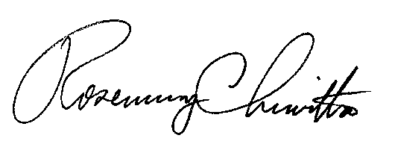
Sincerely,

Rosemary Chiavetta
Secretary

RC:AEL
Enclosure

