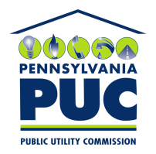 | COMMONWEALTH OF PENNSYLVANIA  PENNSYLVANIA PUBLIC UTILITY COMMISSION  400 NORTH STREET, KEYSTONE BUILDING, SECOND FLOOR  HARRISBURG, PENNSYLVANIA 17120 | IN REPLY PLEASE REFER TO OUR FILE
May 25, 2018

Via Certified Mail

Donna Wasson
Ecova, Inc. / Engie Insight Services Inc.
1313 North Atlantic Street Suite 5000
Spokane WA 99201-2330

RE: Bond Continuation Certificate and Name Change Rider
Ecova, Inc.
A-2011-2234410

Dear Ms. Wasson:

Please find under cover of this letter the financial instrument filed on behalf of Ecova, Inc. because it is not acceptable.

The Commission requires a supplier to file an original bond, letter of credit, continuation certificate, amendment, or other financial instrument as part of a supplier’s licensing requirements under Section 2809(c) of the Pennsylvania Public Utility Code, including naming the Pennsylvania Public Utility Commission as the beneficiary or obligee of the security instrument along with all other required information on the document.

Any financial instruments under a new name can only be accepted for filing after the name change has been approved. As Ecova Inc. did not provide the necessary filing fee in a timely manner, the filing is being returned to you under separate cover.

Sincerely,

Rosemary Chiavetta
Secretary of the Commission

RC: alw
Enclosures

