BEFORE THE
PENNSYLVANIA PUBLIC UTILITY COMMISSION

Karen Feitt and H. Mendoza, Jr. :
:
v. : F-2017-2636316
:
Duquesne Light Company :

INTERIM ORDER
CLOSING THE HEARING RECORD

AND NOW, the transcript of the April 25, 2018, initial hearing in this case having been filed with the Commission’s Secretary’s Bureau in Harrisburg on May 17, 2018; and a copy of the transcript having been received by the undersigned in Pittsburgh on May 25, 2018; and no further hearings in this matter are to be scheduled or held,

THEREFORE,

IT IS ORDERED:

- That the hearing record at Docket No. F-2017-2636316 is closed.

2. That the Initial Decision in this case shall be prepared and issued.

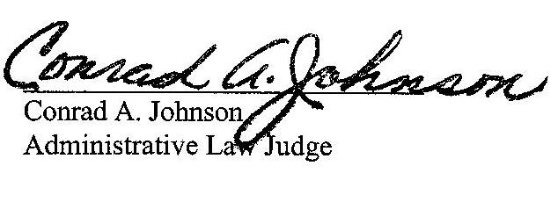
Dated: May 29, 2018

F-2017-2636316 - KAREN FEITT AND H MENDOZA JR v. DUQUESNE LIGHT COMPANY
KAREN FEITT
1036 JACKMAN AVENUE
AVALON PA 15202
412.766.0422
H MENDOZA JR
1036 JACKMAN AVE
AVALON PA 15202
412.499.1822
LAUREN N RULLI ESQUIRE
PAUL SHANE MILLER ESQUIRE
TUCKER ARENSBERG PC
1500 ONE PPG PLACE
PITTSBURGH PA 15222
412.594.5510
412.594.5503
E-SERVICE

