BEFORE THE
PENNSYLVANIA PUBLIC UTILITY COMMISSION

Randy Stewart :
:
v. : C-2018-2642778
:
UGI Utilities, Inc. :

INTERIM ORDER
CLOSING THE HEARING RECORD

AND NOW, the transcript of the May 16, 2018, initial hearing in this case having been filed with the Commission’s Secretary’s Bureau in Harrisburg on May 30, 2018; and a copy of the transcript having been received by the undersigned in Pittsburgh on June 1, 2018; and no further hearings in this matter are to be scheduled or held,

THEREFORE,

IT IS ORDERED:

- That the hearing record at Docket No. C-2018-2642778 is closed.

2. That the Initial Decision in this case shall be prepared and issued.

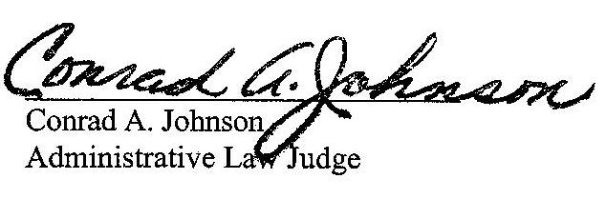
Dated: June 4, 2018

C-2018-2642778 - RANDY STEWART v. UGI UTILITIES, INC (GAS DIVISION)
TODD S STEWART ESQUIRE
HAWKE MCKEON AND SNISCAK LLP
100 NORTH TENTH STREET
HARRISBURG PA 17101
717.236.1300
-E_SERVE-
RANDY STEWART
526 PINE STREET
DENVER PA 17517
717.336.8445
JORGE PEREIRA ESQUIRE
PRINCE LAW OFFICES PC
646 LENAPE ROAD
BECHTELSVILLE PA 19505-9135
610.845.3803
-E-SERVE-

