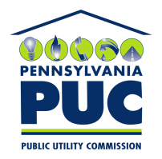 | COMMONWEALTH OF PENNSYLVANIA  PENNSYLVANIA PUBLIC UTILITY COMMISSION  400 North Street, Keystone Building, Second Floor  Harrisburg, Pennsylvania 17120 | IN REPLY PLEASE REFER TO OUR FILE

June 11, 2018

Make the Switch USA LLC
1209 Via Visalia
San Clemente CA 92672

RE: Continuation Certificate
Make the Switch USA LLC
A-2011-2243341

Dear Sir/Madam:

On May 29, 2018, the Commission received your Bond Continuation Certificate extending the term of your Bond to June 1, 2019. This document was seriously damaged during transit, and as such cannot be accepted for filing.

The Commission requires a supplier to file an original bond, letter of credit, continuation certificate, amendment, or other financial instrument as part of a supplier's licensing requirements under Section 2809(c) of the Pennsylvania Public Utility Code, including naming the Pennsylvania Public Utility Commission as the beneficiary or obligee of the security instrument.

Please file a duplicate original financial instrument with my office as soon as possible, preferably by overnight delivery to my office address listed above.

Sincerely,

Rosemary Chiavetta
Secretary of the Commission

RC:aw

