 |  | COMMONWEALTH OF PENNSYLVANIA  PENNSYLVANIA PUBLIC UTILITY COMMISSION  400 North Street, HARRISBURG, PA 17120 |  | IN REPLY PLEASE REFER TO OUR FILE  Phone: 717-772-7777
June 1, 2018

NEW JACK’S TRANSPORT LLC
JACOB A SIMCOX
2348 PAXTONVILLE ROAD
MIDDLEBURG PA 17842

Dear Mr. Simcox:

On June 1, 2018, the Commission received your E-Filed Application of New Jack’s Transport LLC for Motor Common Carrier of Property. Upon initial review, the Application has been determined to be incorrect for the following reasons:

- Item #1, Legal Name of Applicant states New Jack’s Transport LLC. However, the name you are registered with at the Pa Department of State Corporation Bureau at entity number 6684722 is New Jack’s Transportation LLC. The legal name on your Motor Carrier application must match exactly with the registered name with the Department of State. Please correct this by filing a new first page with the correct Legal Name.
Pursuant to 52 Pa. Code §1.4, you are required to correct these items. Failure to do so within 20 days of the date of this letter will result in the Application being returned unfiled.
Please return your items to the above listed address and address to the attention of Secretary Chiavetta. You may also either e-mail this corrected page or fax to 717-787-0974 Attn: Diane Jacob.

Should you have any questions pertaining to your application, please contact our Bureau at 717-772-7777.

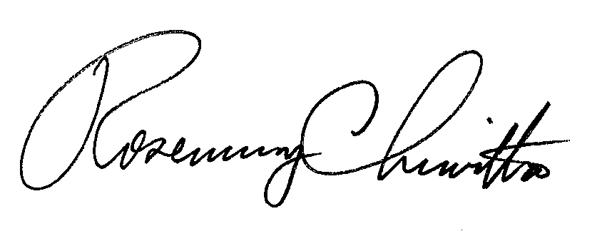
Sincerely,

Rosemary Chiavetta
Secretary

DJ

