 | COMMONWEALTH OF PENNSYLVANIA  PENNSYLVANIA PUBLIC UTILITY COMMISSION  400 NORTH STREET, HARRISBURG, PA 17120 | IN REPLY PLEASE REFER TO OUR FILE

DATE RE-SERVED (2nd attempt): 6/14/2018

C-2018-3001451

SUNOCO PIPELINE, L.P.
1801 MARKET STREET SUITE 1500
PHILADELPHIA, PA 19103-1699

Pennsylvania State Senator Andrew E. Dinniman
v
Sunoco Pipeline, LP

Dear Sir/ Madam:

Attached is copy of an amended complaint filed on behalf of the complainant in the above titled proceeding.

Such answer as you desire to make to the amended complaint should be filed in this Office and served upon the complainant within twenty days from receipt of this letter.

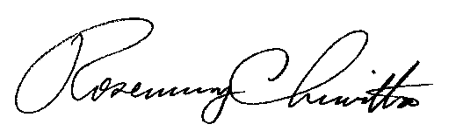
Very truly yours,

Rosemary Chiavetta
Secretary

RC:jbs

