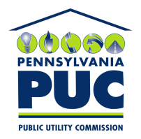 | COMMONWEALTH OF PENNSYLVANIA  PENNSYLVANIA PUBLIC UTILITY COMMISSION  400 NORTH STREET, KEYSTONE BUILDING, SECOND FLOOR  HARRISBURG, PENNSYLVANIA 17120 | IN REPLY PLEASE REFER TO OUR FILE

June 18, 2018

Via Certified Mail

Karen White, Regulatory Compliance
Verde Energy USA Inc.
12140 Wickchester Lane Suite 100
Houston TX 77079

RE: Bond Continuation Certificate
Verde Energy USA Inc.
A-2010-2151038

Dear Ms. White:

Please find under cover of this letter the financial instrument filed with the Commission on behalf of Verde Energy USA Inc. because it is a photocopy, and not acceptable.

The Commission requires a supplier to file an original bond, letter of credit, continuation certificate, amendment, or other financial instrument as part of a supplier’s licensing requirements under Section 2809(c) of the Pennsylvania Public Utility Code.

The enclosed financial instrument does not have a "wet ink" original signature or raised seal for the surety company. Please file the original financial instrument with my office within 20 days of the date of this letter, preferably by overnight delivery to my office address listed above.

Sincerely,

Rosemary Chiavetta
Secretary of the Commission

RC: alw
Enclosures

