 | COMMONWEALTH OF PENNSYLVANIA  PENNSYLVANIA PUBLIC UTILITY COMMISSION  P.O. BOX 3265, HARRISBURG, PA 17105-3265 | IN REPLY PLEASE REFER TO OUR FILE
June 19, 2018
A-2018-3002437
Utility Code: 230073
David P. Zambito, Esquire
George A. Bibikos, Esquire
Jonathan Nase, Esquire
Cozen O’Connor
17 North Second Street
Suite 1410
Harrisburg, P A 17101

Dear Attorney Zambito:

Receipt is acknowledged of the Application of Pennsylvania-American Water Company-Wastewater, pursuant to the Pennsylvania Public Utility Code, 66 Pa C.S. §1102(a), and 66 Pa. C.S. §1329 for approval of (1) the transfer, by sale, of substantially all of the Township of Sadsbury's assets, properties and rights related to its wastewater collection system to Pennsylvania-American Water Company, and (2) the rights of Pennsylvania-American Water Company to begin to offer or furnish wastewater service to the public in a portion of the Township of Sadsbury, Chester County, Pennsylvania, which has been docketed to the above number.

It will be necessary for you to serve copies of the Application upon the following parties, then file proof of such service with this Commission, pursuant to 52 Pa. Code, §1.57 and §1.58:

Each city, borough, town, township, county and related planning office which is included, in whole or in part, in the proposed service area;

A water or wastewater utility, municipal corporation or authority which provides water or wastewater collection, treatment and disposal service to the public and whose service area abuts the service area proposed in the application;

And the Department of Environmental Protection’s appropriate regional office.

You are directed upon receipt of this letter to publish the enclosed notice once a week for two consecutive weeks in a newspaper having a general circulation in the area involved and file proof of publication with the Commission on or before July 16, 2018.

Pursuant to 52 Pa. Code §5.14, the Commission will proceed with publishing the attached notice in the Pennsylvania Bulletin. This notice will appear in the Saturday, June 30, 2018 issue.

This matter will receive the attention of the Commission and you will be advised of any further necessary procedure.

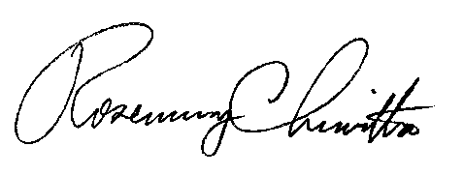
Sincerely,

Rosemary Chiavetta
Secretary

Enclosure

cc: Susan Simms Marsh, Esquire

PENNSYLVANIA PUBLIC UTILITY COMMISSION
NOTICE TO BE PUBLISHED

Application of Pennsylvania-American Water Company-Wastewater, pursuant to the Pennsylvania Public Utility Code, 66 Pa C.S. §1102(a), and 66 Pa. C.S. §1329 for approval of (1) the transfer, by sale, of substantially all of the Township of Sadsbury's assets, properties and rights related to its wastewater collection system to Pennsylvania-American Water Company, and (2) the rights of Pennsylvania-American Water Company to begin to offer or furnish wastewater service to the public in a portion of the Township of Sadsbury, Chester County, Pennsylvania. Docket Number: A-2018-3002437.
________________________________________________

Formal protests and petitions to intervene must be filed in accordance with Title 52 of the Pennsylvania Code, on or before July 16, 2018. All filings must be made with the Secretary of the Pennsylvania Public Utility Commission, P. O. Box 3265, Harrisburg, PA 17105-3265, with a copy served on the Applicant. The documents filed in support of the Application are available for inspection and copying at the Office of the Secretary between the hours of 8:00 a.m. and 4:30 p.m., Monday through Friday, on the Commission's website at www.puc.pa.gov, and at the Applicant's business address.

Applicant:

Pennsylvania American Water Company - Wastewater

Through and By Counsel for:

David P. Zambito, Esquire
George A. Bibikos, Esquire
Jonathan Nase, Esquire
Cozen O’Connor
17 North Second Street
Suite 1410
Harrisburg, P A 17101

AND

Susan Simms Marsh, Esquire
Pennsylvania-American Water Company
800 West Hershey Park Drive
Hershey, PA 17033

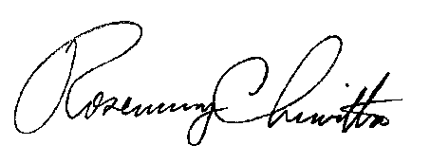
BY THE COMMISSION

Rosemary Chiavetta
Secretary

