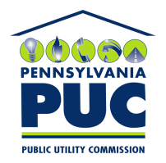 | COMMONWEALTH OF PENNSYLVANIA  PENNSYLVANIA PUBLIC UTILITY COMMISSION  400 North Street, Keystone Building, Second Floor  Harrisburg, Pennsylvania 17120 | IN REPLY PLEASE REFER TO OUR FILE

July 19, 2018
Via Certified Mail

Brian Cross
Xencom Green Energy LLC
1609 Precision Drive Suite 3000
Plano TX 75074

RE: Continuation Certificate
Xencom Green Energy LLC
A-2010-2192916

Dear Mr. Cross:

Per your telephone conversation with Secretary’s Bureau staff on July 19, 2018, enclosed please find your duplicate bond, which is not needed. The Continuation Certificate that was submitted at the same time has been accepted for filing, and on approval by Technical Utility Services staff, will extend your bond to September 14, 2019.

Please also note that this Bond is based on an outdated template; if in future you wish to submit a new bond, please see the Electric Generation Supplier Application packet on the Commission website for the most recent version.

Thank you for your attention to the matter.

Sincerely,

Rosemary Chiavetta
Secretary of the Commission

RC:alw

