 | COMMONWEALTH OF PENNSYLVANIA  PENNSYLVANIA PUBLIC UTILITY COMMISSION  400 NORTH STREET, HARRISBURG, PA 17120 | IN REPLY PLEASE REFER TO OUR FILE
June 27, 2018

TIMOTHY J. MIKOTOWICZ, PRESIDENT
ERIE ENERGY PARTNERS LLC
3505 CHAPIN STREET
ERIE, PA 16508

Dear Mr. Mikotowicz:

On June 22, 2018, the Commission received the Application of Erie Energy Partners LLC for approval to supply natural gas services to the public in the Commonwealth of PA. Upon initial review, the Application has been determined to be missing information for the following reason:

- Proofs of Publication must be in their original form. Copies of Proofs of Publication will not be accepted.

Pursuant to 52 Pa. Code §1.4, you are being advised of this missing information and are required to file corrections. Failure to correct the foregoing missing information within 20 days of the date of this letter will result in the Application being returned unfiled.
Please return your item to the above listed address and address to the attention of the Office of the Secretary.
If you have any question in regards to this letter, please contact our bureau at (717) 772-7777. Thank you
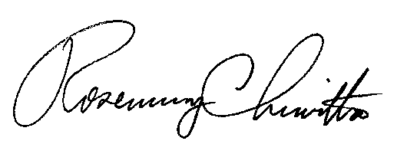
Sincerely,

Rosemary Chiavetta
Secretary

RC:AEL
Enclosure

