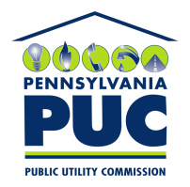 | COMMONWEALTH OF PENNSYLVANIA  PENNSYLVANIA PUBLIC UTILITY COMMISSION  400 North Street, Keystone Building, Second Floor  Harrisburg, Pennsylvania 17120 | IN REPLY PLEASE REFER TO OUR FILE

August 1, 2018

Ms. Michelle Sanchez
Health Trust Purchasing Group LP
1100 Charlotte Avenue Suite 1100
Nashville TN 37203

RE: Duplicate Financial Instrument
Health Trust Purchasing Group LP
A-2009-2145163

Dear Ms. Sanchez:

Please find under cover of this letter the continuation certificate you filed with the Commission on behalf of Health Trust Purchasing Group LP because it is a duplicate of the continuation already on file. The continuation certificate filed on February 20, 2018 lists the same expiration date as this one.

The Commission requires a supplier to file a current and active original bond, letter of credit, continuation certificate, amendment, or other financial instrument as part of a supplier’s licensing requirements under Section 2809(c) of the Pennsylvania Public Utility Code.

Your financial instrument filed with the Commission expires on November 30, 2018. Please note that the above referenced Financial Instrument applies only your operations as an Electric Generation Supplier, and not to your operations as a Natural Gas Supplier (application in process at docket number A-2012-2327971).

Sincerely,

Rosemary Chiavetta
Secretary of the Commission

Enclosures
RC:alw

