 | COMMONWEALTH OF PENNSYLVANIA  PENNSYLVANIA PUBLIC UTILITY COMMISSION  P.O. BOX 3265, HARRISBURG, PA 17105-3265 | IN REPLY PLEASE REFER TO OUR FILE
August 8, 2018
A-2018-3003517
Utility Code: 230077
David P. Zambito, Esquire
Jonathan Nase, Esquire
Cozen O’Connor
17 North Second Street
Suite 1410
Harrisburg, P A 17101

Dear Attorney Zambito:

Receipt is acknowledged of the Application of Suez Water Pennsylvania, Inc., pursuant to the Pennsylvania Public Utility Code, 66 Pa C.S. §1102(a), and 66 Pa. C.S. §1329 for 1) approval of
the transfer, by sale, of substantially all of the Township of Mahoning's assets, properties and rights related to its Wastewater collection and conveyance system to SUEZ Water Pennsylvania Inc., and 2) the rights of SUEZ Water Pennsylvania Inc. to begin to offer or furnish Wastewater collection and conveyance service to the public in portions of the Townships of Mahoning, Cooper and Valley, Montour County, Pennsylvania, which has been docketed to the above referenced number.

It will be necessary for you to serve copies of the Application upon the following parties, then file proof of such service with this Commission, pursuant to 52 Pa. Code, §1.57 and §1.58:

Each city, borough, town, township, county and related planning office which is included, in whole or in part, in the proposed service area;

A water or wastewater utility, municipal corporation or authority which provides water or wastewater collection, treatment and disposal service to the public and whose service area abuts the service area proposed in the application;

And the Department of Environmental Protection’s appropriate regional office.

You are directed upon receipt of this letter to publish the enclosed notice once a week for two consecutive weeks in a newspaper having a general circulation in the area involved and file proof of publication with the Commission on or before Tuesday, September 4, 2018.

Pursuant to 52 Pa. Code §5.14, the Commission will proceed with publishing the attached notice in the Pennsylvania Bulletin. This notice will appear in the Saturday, August 18, 2018 issue.

This matter will receive the attention of the Commission and you will be advised of any further necessary procedure.

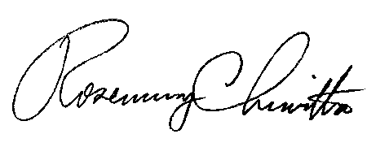
Sincerely,

Rosemary Chiavetta
Secretary

Enclosure

Cc: Bureau of Investigation and Enforcement
Office of Consumer Advocate
Office of Small Business Advocate
Office of Attorney General

PENNSYLVANIA PUBLIC UTILITY COMMISSION
NOTICE TO BE PUBLISHED

Application of Suez Water Pennsylvania, Inc., pursuant to the Pennsylvania Public Utility Code, 66 Pa C.S. §1102(a), and 66 Pa. C.S. §1329 for approval of the transfer, by sale, of substantially all of the Township of Mahoning's assets, properties and rights related to its wastewater collection and conveyance system to SUEZ Water Pennsylvania Inc., and 2) the rights of SUEZ Water Pennsylvania Inc. to begin to offer or furnish wastewater collection and conveyance service to the public in portions of the Townships of Mahoning, Cooper and Valley, Montour County, Pennsylvania. Docket Number: A-2018-3003517.
________________________________________________

Formal protests and petitions to intervene must be filed in accordance with Title 52 of the Pennsylvania Code, on or before Tuesday, September 4, 2018. All filings must be made with the Secretary of the Pennsylvania Public Utility Commission, P. O. Box 3265, Harrisburg, PA 17105-3265, with a copy served on the Applicant. The documents filed in support of the Application are available for inspection and copying at the Office of the Secretary between the hours of 8:00 a.m. and 4:30 p.m., Monday through Friday, on the Commission's website at www.puc.pa.gov, and at the Applicant's business address.

Applicant:

Suez Water Pennsylvania, Inc.

Through and By Counsel for:

David P. Zambito, Esquire
Jonathan Nase, Esquire
Cozen O’Connor
17 North Second Street
Suite 1410
Harrisburg, P A 17101

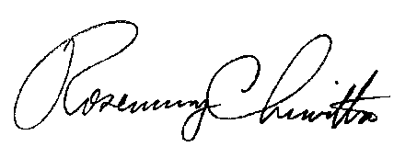
BY THE COMMISSION

Rosemary Chiavetta
Secretary

