 |  | COMMONWEALTH OF PENNSYLVANIA  PENNSYLVANIA PUBLIC UTILITY COMMISSION  400 North Street, HARRISBURG, PA 17120 |  | IN REPLY PLEASE REFER TO OUR FILE  Phone: 717-772-7777

August 10, 2018

C-2018-3003898

KIMBERLY A. KLOCK, ESQUIRE
PPL ELECTRIC UTILITIES CORPORATION
TWO NORTH 9TH STREET, GENTW4
ALLENTOWN, PA 18101-1179

Chastity Amlong
v.
PPL Electric Utilities Corporation

Dear Sir/Madam:

Attached is a copy of an amended complaint filed on behalf of the complainant in the above titled proceeding.

Such answer as you desire to make to the amended complaint should be filed in this Office and served upon the complainant within twenty days from receipt of this letter.

Very truly yours,
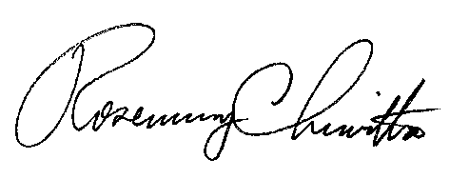

Rosemary Chiavetta
Secretary

cc: File

RC:AEL

